PROCUREMENTIQ AI - LangGraph, PyMuPDF, ReportLab - Gemini 1.5 Flash

Project Description:
ProcurementIQ AI is an AI-powered procurement intelligence web application that turns supplier quotations into explainable vendor recommendations. Procurement teams upload quotations in PDF, Excel, or CSV format, and a six-agent pipeline parses the purchase requirements, normalizes every quotation, researches supplier history, scores supply-chain risk, calculates the total landed cost, and ranks the vendors, so that a buyer can compare suppliers on evidence instead of guesswork. The platform is built with Flask, Jinja2 templates, a custom pastel enterprise design system, and a SQLite database.
Every recommendation is transparent. Vendors are scored on Total Cost (40%), Delivery Performance (25%), Risk (20%), and Warranty & Support (15%), and any vendor that breaks a mandatory constraint (over budget, late delivery, or below the minimum warranty) is explicitly disqualified
Scenarios
Scenario 1: A procurement specialist creates a request for five industrial transformers with a USD 100,000 budget, a 15 November 2026 delivery deadline, and a 24-month minimum warranty, then loads three supplier quotations (a PDF, an Excel sheet, and a CSV file). The app extracts the commercial figures from every file and shows them on an editable review screen with an extraction-confidence badge, marking any field a supplier did not provide as “Not provided” instead of guessing.
Scenario 2: The buyer confirms the quotations and runs the agents one by one on the AI Agent Workflow page. The Requirement Parser turns the request into mandatory constraints, the Quote Analyzer normalizes the three quotes, the Supplier Researcher compiles each vendor’s on-time delivery rate and audit evidence, the Risk Assessor assigns risk scores with mitigation steps, and the Cost Optimizer calculates the landed cost of every offer.
Scenario 3: The Procurement Advisor Agent ranks the suppliers with the weighted scoring engine and marks any vendor that exceeds the budget, misses the deadline, or falls below the minimum warranty as “Not Eligible”. The buyer opens the Vendor Recommendations page, reviews the score breakdown and negotiation tips, and either approves the recommended supplier or overrides it by choosing another vendor with a written justification, which is saved in the decision history.
Scenario 4: A manager changes the scoring weights on the Settings page, for example giving delivery more importance than cost. The next run of the Procurement Advisor re-ranks the vendors with the new weights, and the Executive PDF and CSV reports on the Reports page can be downloaded for the contract file and for ERP import.

Technical Architecture:
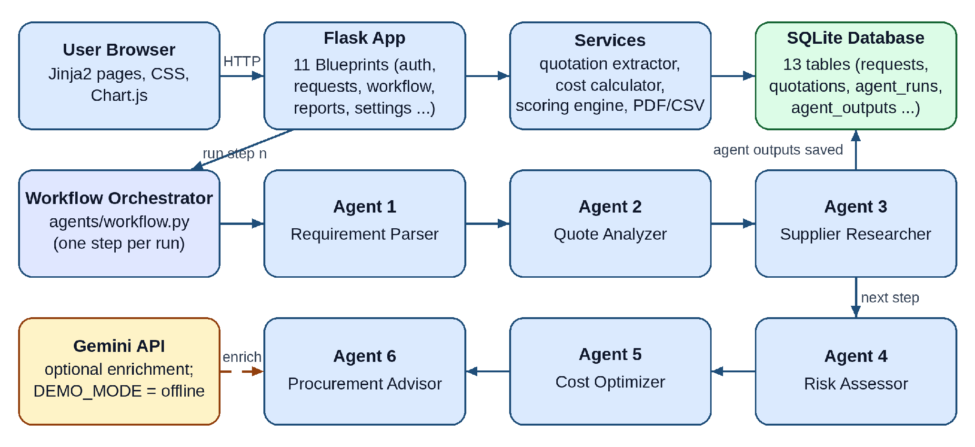

Pre-requisites:
Flask Framework Knowledge: Flask Documentation
Google Gemini API Familiarity: Gemini API Documentation
LangGraph and Multi-Agent Concepts: LangGraph Documentation
SQLite and SQL Basics: SQLite Documentation
HTML, CSS, and JavaScript Skills: W3Schools HTML/CSS/JavaScript Tutorials
Python Programming Proficiency: Python Documentation
Document Parsing (PDF and Excel): PyMuPDF Documentation
PDF Report Generation: ReportLab Documentation
Version Control with Git: Git Documentation
Development Environment Setup: Flask Installation Guide
Ngrok for Public Deployment: Ngrok Documentation

Project Workflow:

Activity 1: Model Selection and Architecture
- Activity 1.1: Generate a Gemini API key and configure it securely in the project environment (optional, because the app also runs in offline DEMO MODE).
- Activity 1.2: Research and select the appropriate generative AI model from Google Gemini and decide between the LLM execution mode and the offline DEMO MODE.
- Activity 1.3: Define the architecture of the application, detailing the interactions between the Flask blueprints, the six-agent workflow, the services, the SQLite database, and the AI layer.
- Activity 1.4: Set up the development environment, installing the necessary libraries and dependencies for Flask, PyMuPDF, openpyxl, ReportLab, LangGraph, and Gemini.

Activity 2: Core Functionalities Development
- Activity 2.1: Develop the six procurement agents together with the transparent scoring engine and the landed-cost calculator.
- Activity 2.2: Implement the Flask backend to manage the SQLite database, quotation extraction, user sessions, and the step-by-step agent workflow.

Activity 3: App.py Development
- Activity 3.1: Write the application factory in app.py, register the eleven route blueprints, and connect the workflow, Gemini enrichment, and report generation.

Activity 4: Frontend Development
- Activity 4.1: Design the user interface with Jinja2 templates and the Pastel Enterprise CSS design system.
- Activity 4.2: Create dynamic dashboards and agent-result views with Chart.js and lightweight vanilla JavaScript.

Activity 5: Deployment
- Activity 5.1: Prepare the application for local deployment by configuring the environment and installing all dependencies.
- Activity 5.2: Test the application locally, then deploy it publicly with Ngrok to expose the Flask server through a secure URL.
Activity 6: Conclusion

Milestone 1: Model Selection and Architecture
In this milestone, we focus on selecting the generative AI model that enriches the six procurement agents, securing the API key, defining the overall architecture of the application, and preparing the development environment.

Activity 1.1: Generate a Gemini API Key
ProcurementIQ AI works out of the box in DEMO MODE, but to let the Google Gemini API write richer natural-language explanations for each agent you need a valid API key. Follow the steps below to create one and keep it secure.
Step 1 — Create a Google Account and Open Google AI Studio: Visit https://aistudio.google.com and sign in with your Google account.
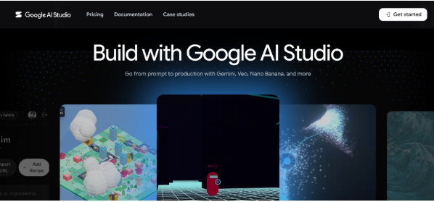
- Step 2 — Navigate to API Keys: Click “Get API key” in the left sidebar, or go directly to https://aistudio.google.com/app/apikey.
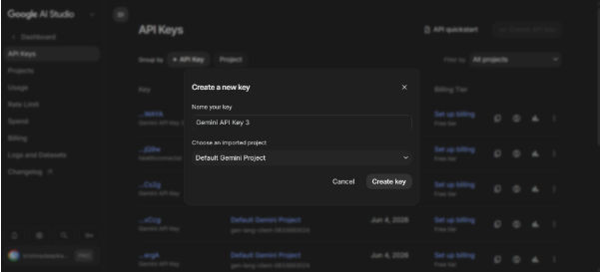
- Step 3 — Create and Copy the API Key: Click “Create API key”, select an existing Google Cloud project or create a new one, and copy the key immediately. Store it somewhere safe.
- Step 4 — Add the Key to Your Project: Copy .env.example to .env in the project root and paste the key as shown below. Setting DEMO_MODE=true keeps every agent running locally without any key.
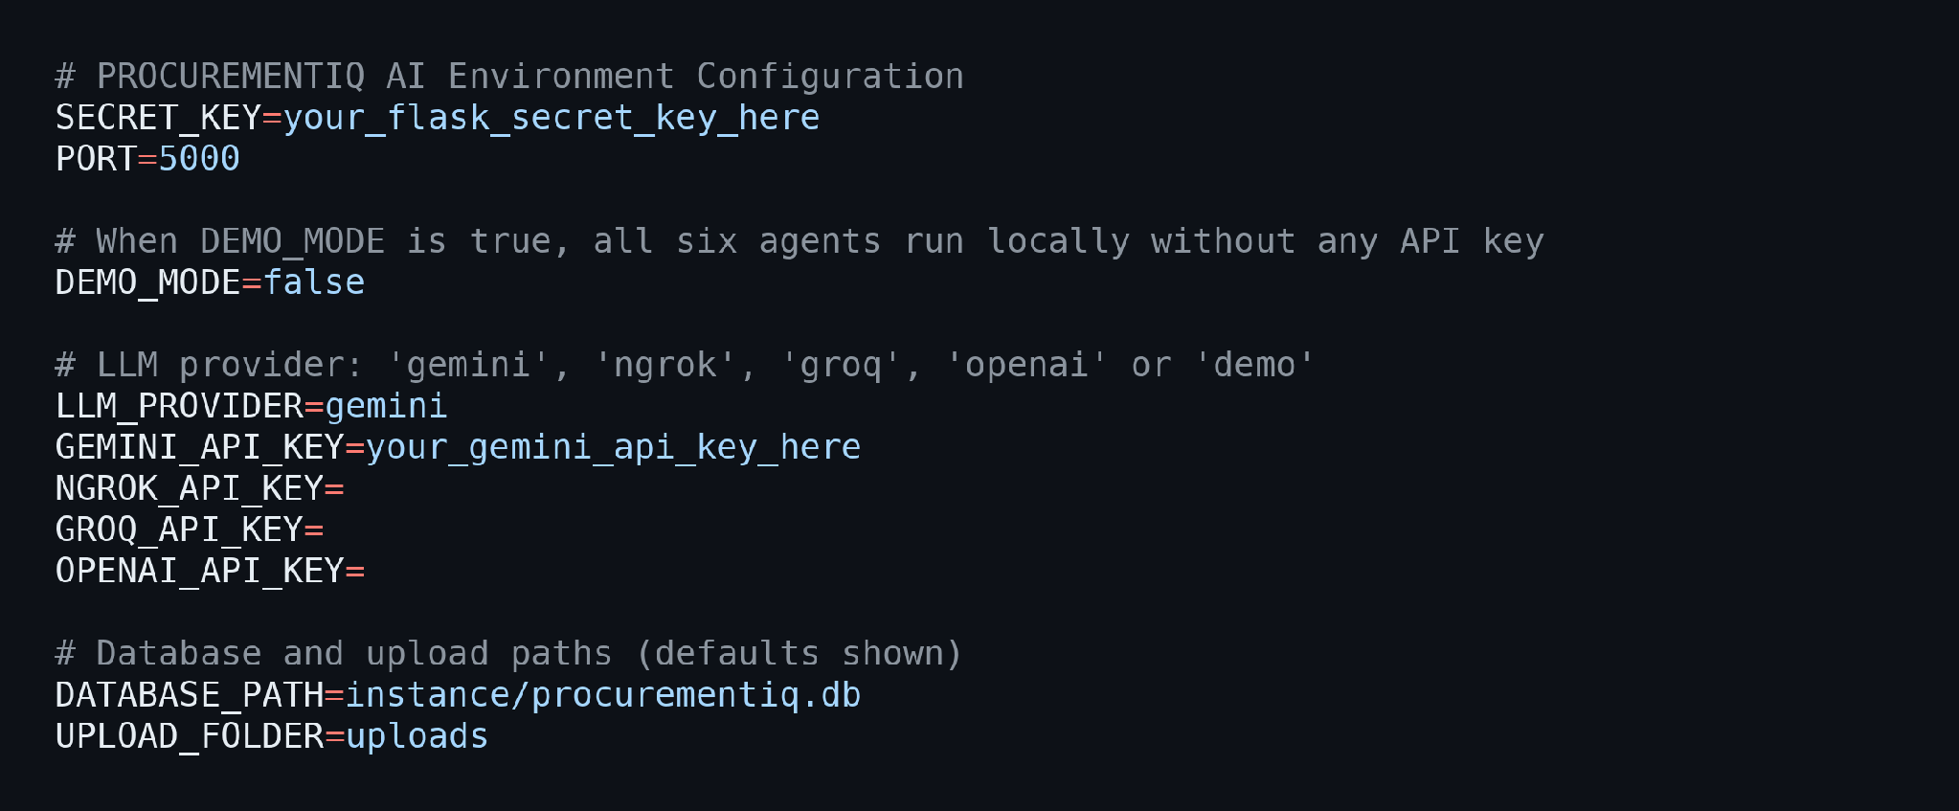
- Step 5 — Verify the Key Is Loaded: config.py loads the .env file with python-dotenv when the app starts and exposes the keys, the DEMO_MODE flag, the upload limits, and the default scoring weights through the Config class.
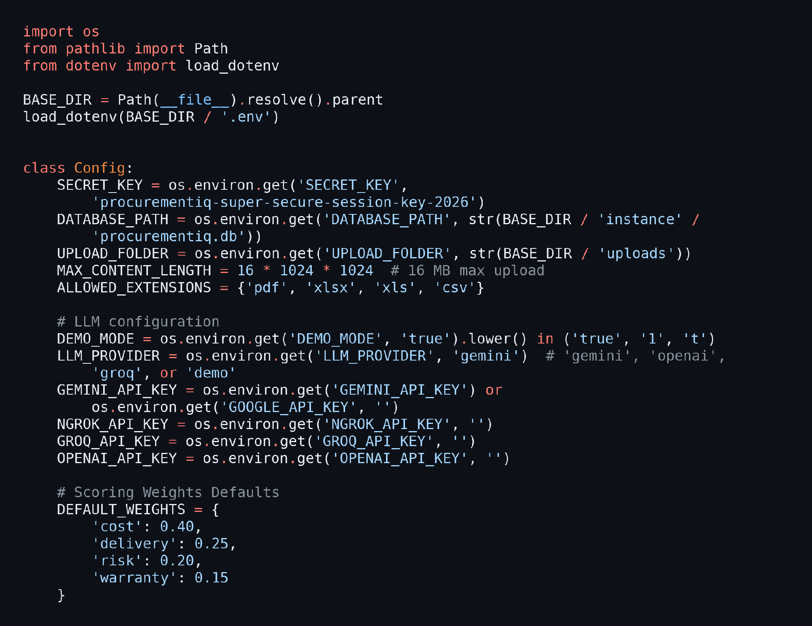
- Step 6 — Test the Connection from the App: Open the Settings page, enter the key, and use the Gemini connection test. The app tries the supported Gemini models in order and reports which one answered.
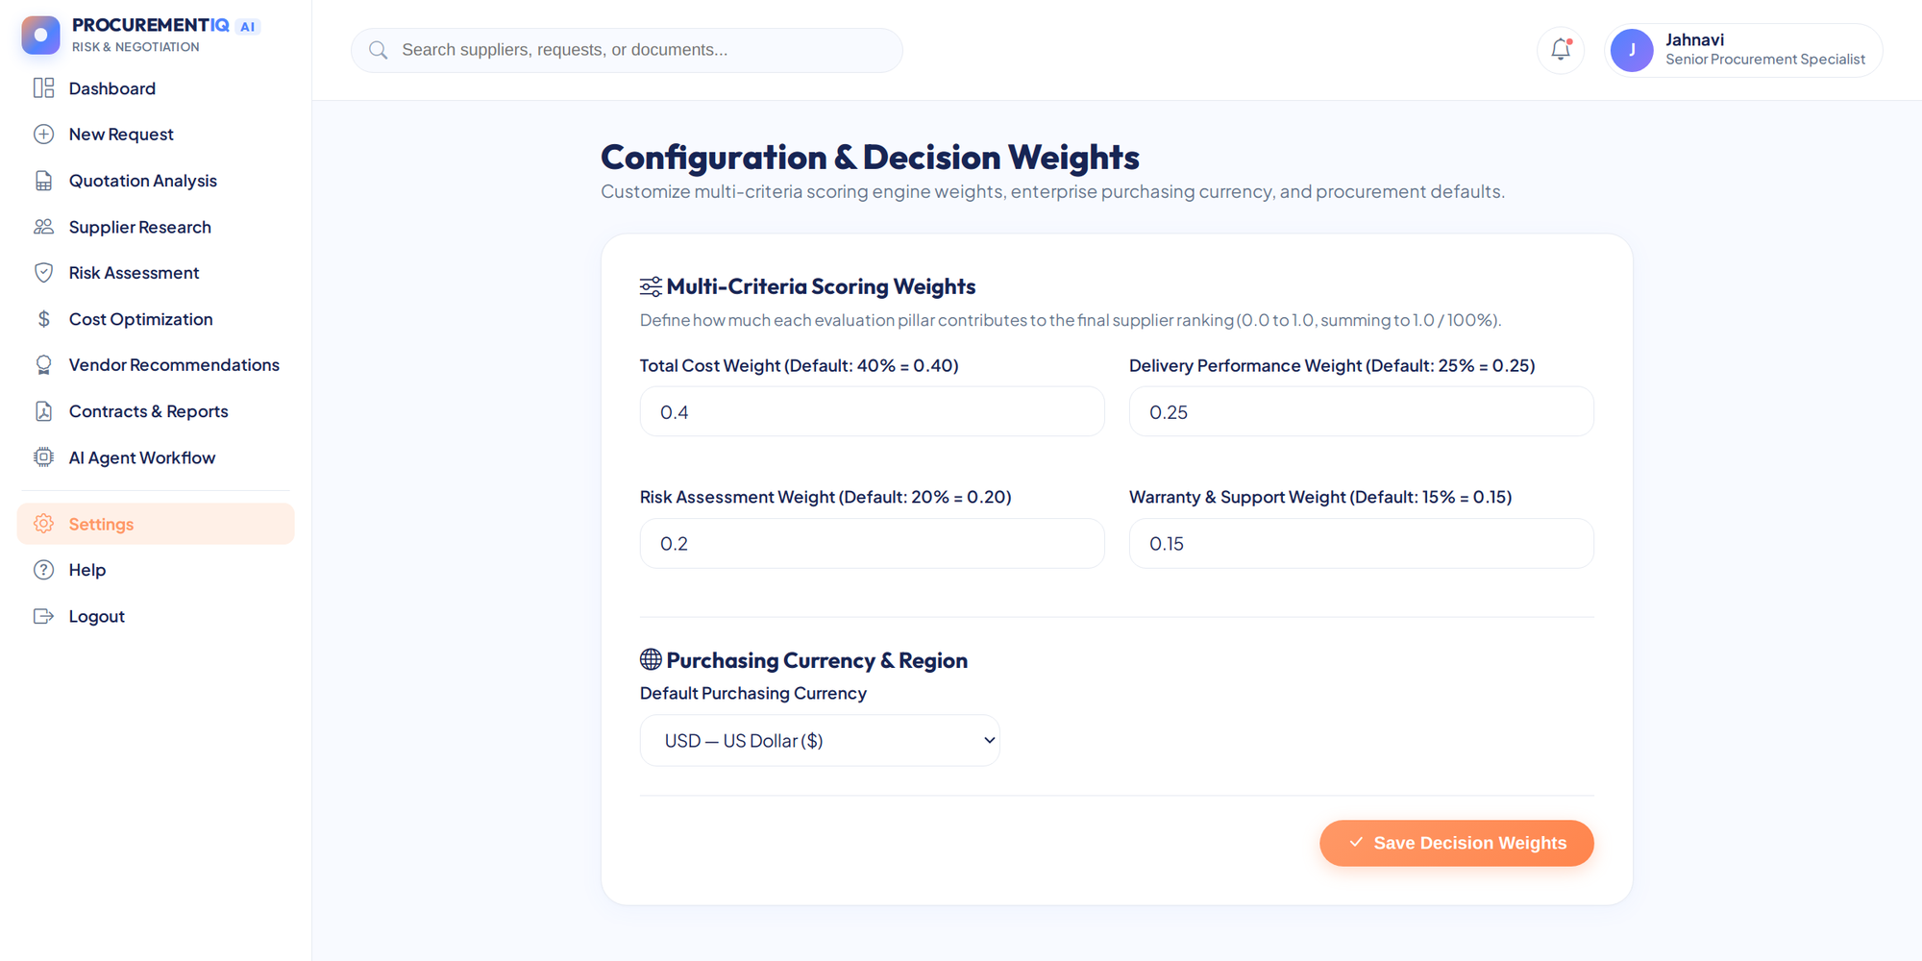
- Important — Never Commit Your API Key: Keep .env out of version control. The project .gitignore already contains the following entry:
.env

Activity 1.2: Research and Select the Appropriate Generative AI Model
- Understand the Project Requirements: Review what the agents need from a language model: short, explainable summaries and key findings for each of the six steps, returned as strict JSON so that the numbers shown to the buyer always come from the deterministic calculators.
- Explore Google’s Model Documentation: Visit the Gemini API documentation to compare the available Flash and Pro models by speed, cost, and JSON-output support.
- Evaluate Model Performance: Because the model is called once per agent step, fast response time and low cost matter more than very large context windows.
- Select the Optimal Model: Use gemini-2.5-flash as the primary model with a temperature of 0.2 and a JSON response type. If it is unavailable, the helper automatically falls back to gemini-flash-latest, gemini-2.0-flash, gemini-1.5-flash, and gemini-1.5-pro.
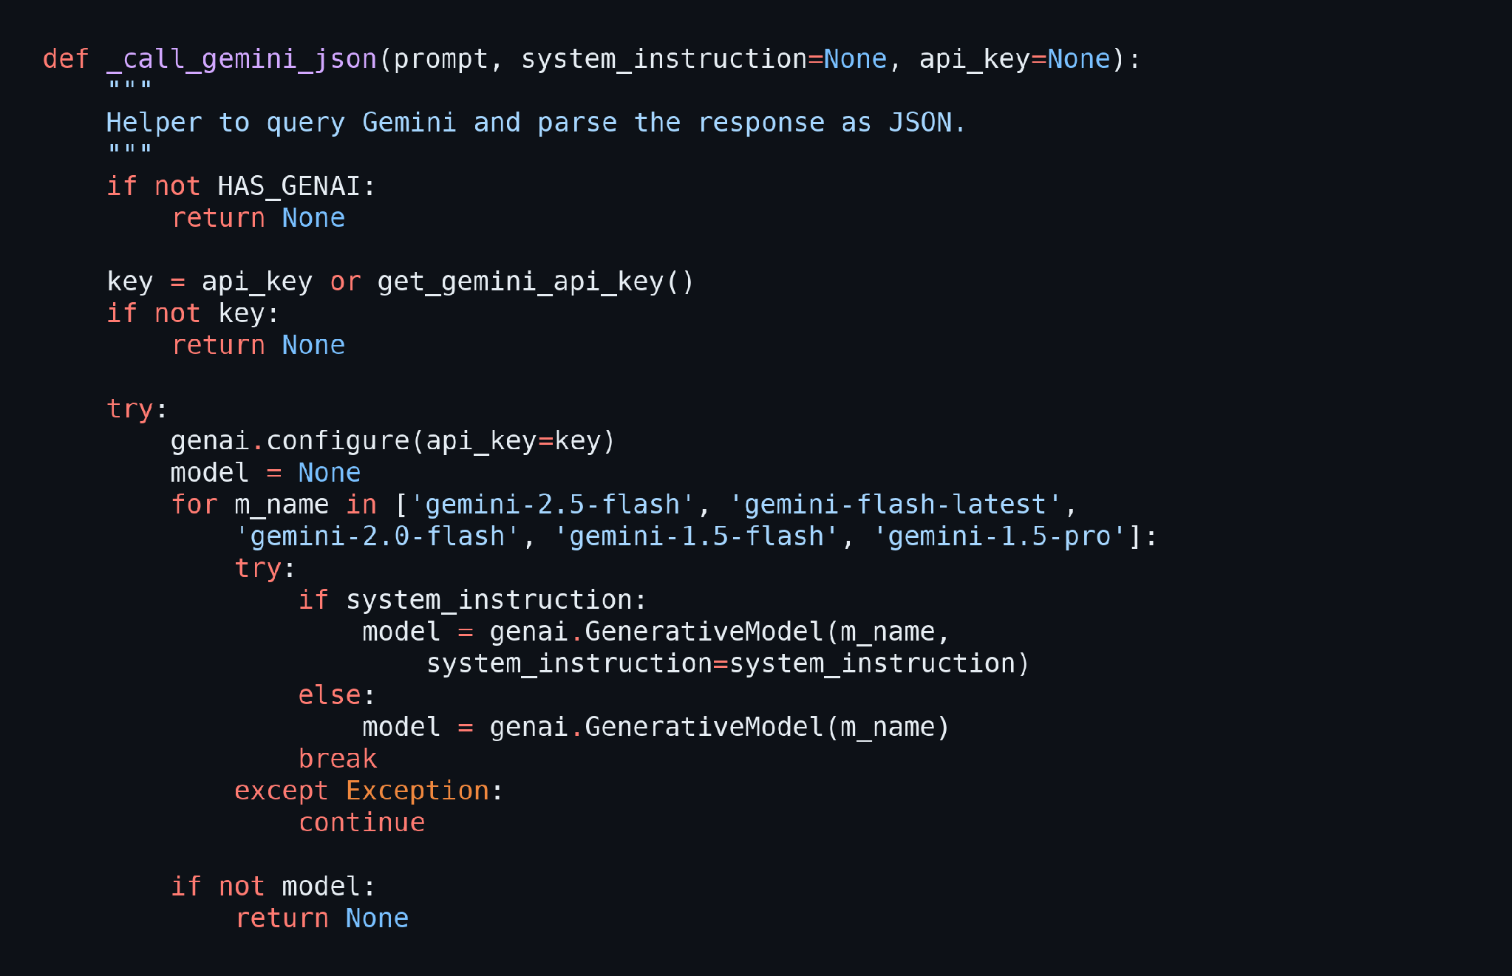
- Choose the Execution Mode: When DEMO_MODE is true, or when no key is available, the workflow records the run as DEMO_FALLBACK and uses the offline deterministic engine. With a key and LangGraph installed, the run is recorded as LLM_LANGGRAPH.

Activity 1.3: Define the Architecture of the Application
- Draft an Architectural Overview: Create a high-level view (shown in the Technical Architecture diagram) of the browser, the Flask application with its eleven blueprints, the services layer, the six-agent workflow, and the SQLite database.
- Detail Frontend Functionality: Outline how users interact with Jinja2 pages for requests, quotation review, supplier research, risk assessment, cost optimization, recommendations, reports, and settings, all inside one sidebar layout.
- Outline Backend Responsibilities: Specify how Flask handles authentication, request creation, quotation upload and extraction, the one-step-at-a-time agent runs, decision recording, and the PDF and CSV exports.
- Describe the Agent Pipeline: Define the six agents in order: Requirement Parser, Quote Analyzer, Supplier Researcher, Risk Assessor, Cost Optimizer, and Procurement Advisor. Each step can only run after its prerequisites are complete, and its output is stored in SQLite.
- Describe the Data Layer: Plan the thirteen SQLite tables, including users, procurement_requests, suppliers, quotations, risk_assessments, cost_comparisons, recommendations, agent_runs, agent_outputs, decision_history, and user_settings.
- Describe the AI Integration Points: Define how services/gemini_service.py enriches each step with Gemini and how every call falls back to the local engine if the key is missing or the request fails.

Activity 1.4: Set Up the Development Environment
- Install Python and Pip: Ensure Python 3.10 or higher is installed on your machine along with pip for dependency management.
- Create a Virtual Environment: Set up a virtual environment to isolate the project dependencies:
python -m venv procurementiq-env
procurementiq-env\Scripts\activate # For Windows
source procurementiq-env/bin/activate # For macOS/Linux
- Install the Project Dependencies: requirements.txt lists Flask, Werkzeug, Jinja2, pandas, numpy, PyMuPDF, openpyxl, ReportLab, LangGraph, LangChain, python-dotenv, and requests. Install them with one command:
pip install -r requirements.txt
- Install the Gemini SDK: The Gemini helper imports the google-generativeai package, so install it as well when you want to use the LLM mode:
pip install google-generativeai
- Configure the Environment File: Copy .env.example to .env and set the values described in Activity 1.1.
- Set Up the Application Structure: Create the project directory structure with the folders for agents, database, routes, services, static assets, and templates, plus app.py, config.py, requirements.txt, and the .env files:
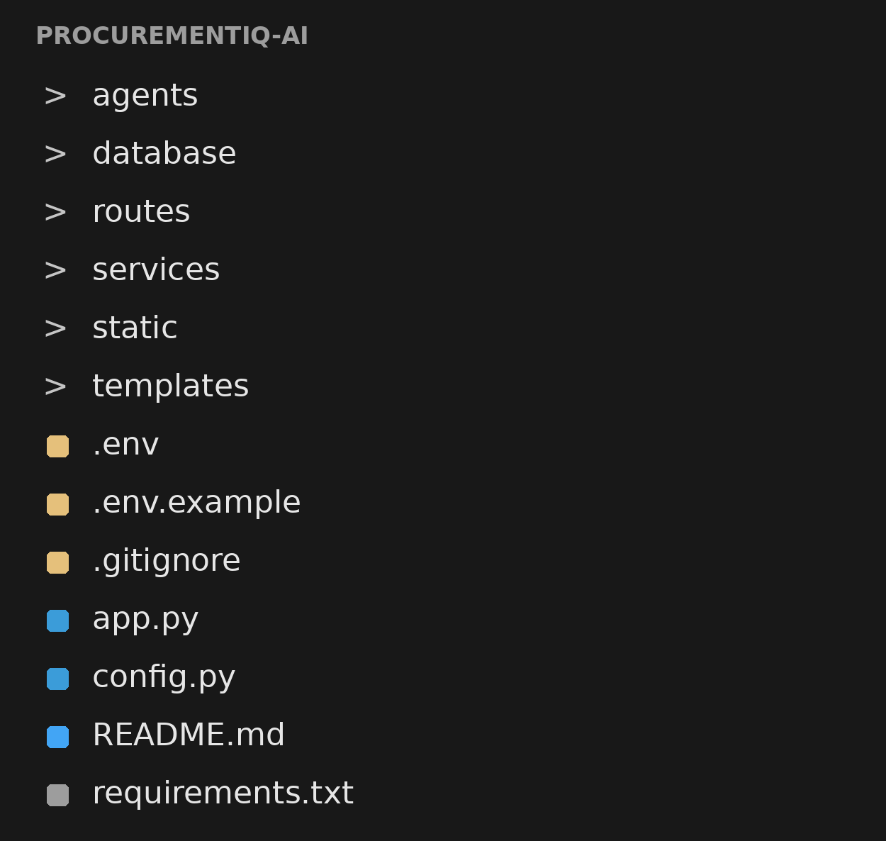

Milestone 2: Core Functionalities Development
Milestone 2 focuses on building the six procurement agents, the transparent scoring engine, the landed-cost calculator, and the Flask backend that stores and orchestrates every step.

Activity 2.1: Develop the Six Procurement Agents
Each agent is a separate Python class inside the agents package, and all six are created by the workflow orchestrator so that they share the same optional LLM client.
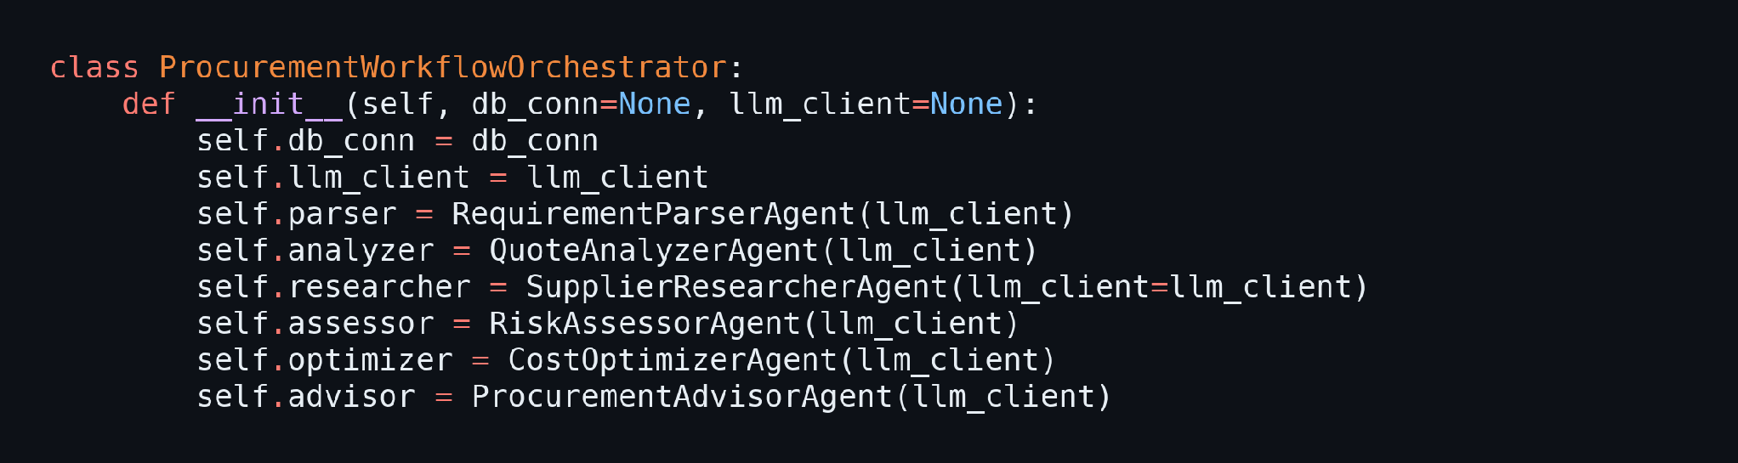
Define the Agent Classes:
- Requirement Parser Agent: Extracts the mandatory constraints (budget ceiling, delivery deadline, minimum warranty) and the commercial preferences from the procurement request.
- Quote Analyzer Agent: Normalizes the quotation line items, discounts, shipping, taxes, and currency, and flags every field that a supplier did not provide.
- Supplier Researcher Agent: Collects each vendor’s historical on-time delivery rate, defect rate, factory audit evidence, and reliability score, and lists the information gaps.
- Risk Assessor Agent: Evaluates delivery deadline compliance, warranty gaps, payment exposure, documentation quality, and single-source dependency with transparent rules, as shown below.
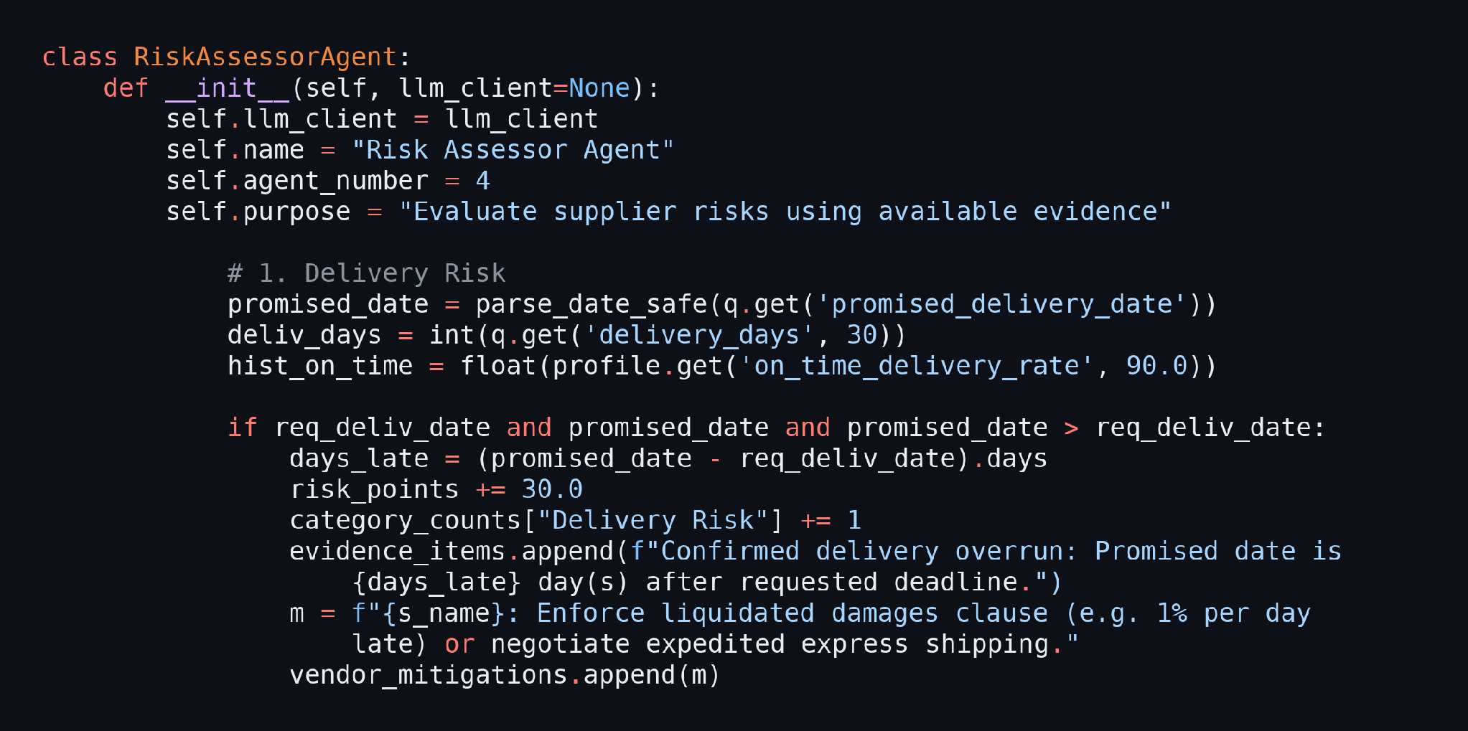
- Cost Optimizer Agent: Calculates the landed cost of every quotation and the variance against the approved budget.
- Procurement Advisor Agent: Scores and ranks the vendors, applies the constraint gates, and writes the trade-off analysis and negotiation tips.
Implement the Transparent Scoring Engine:
- Normalize the Weights: services/scoring_engine.py reads the four weights (cost 40%, delivery 25%, risk 20%, warranty 15% by default) and rescales them so they always add up to 100%.
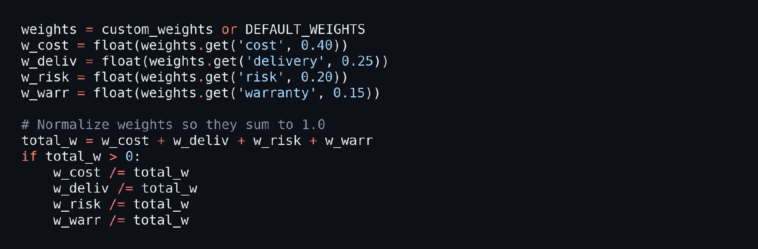
- Apply the Mandatory Constraint Gates: A quotation that exceeds the budget, promises delivery after the deadline, or offers less than the minimum warranty is disqualified with a clear reason. The cost score is then calculated relative to the cheapest quote.
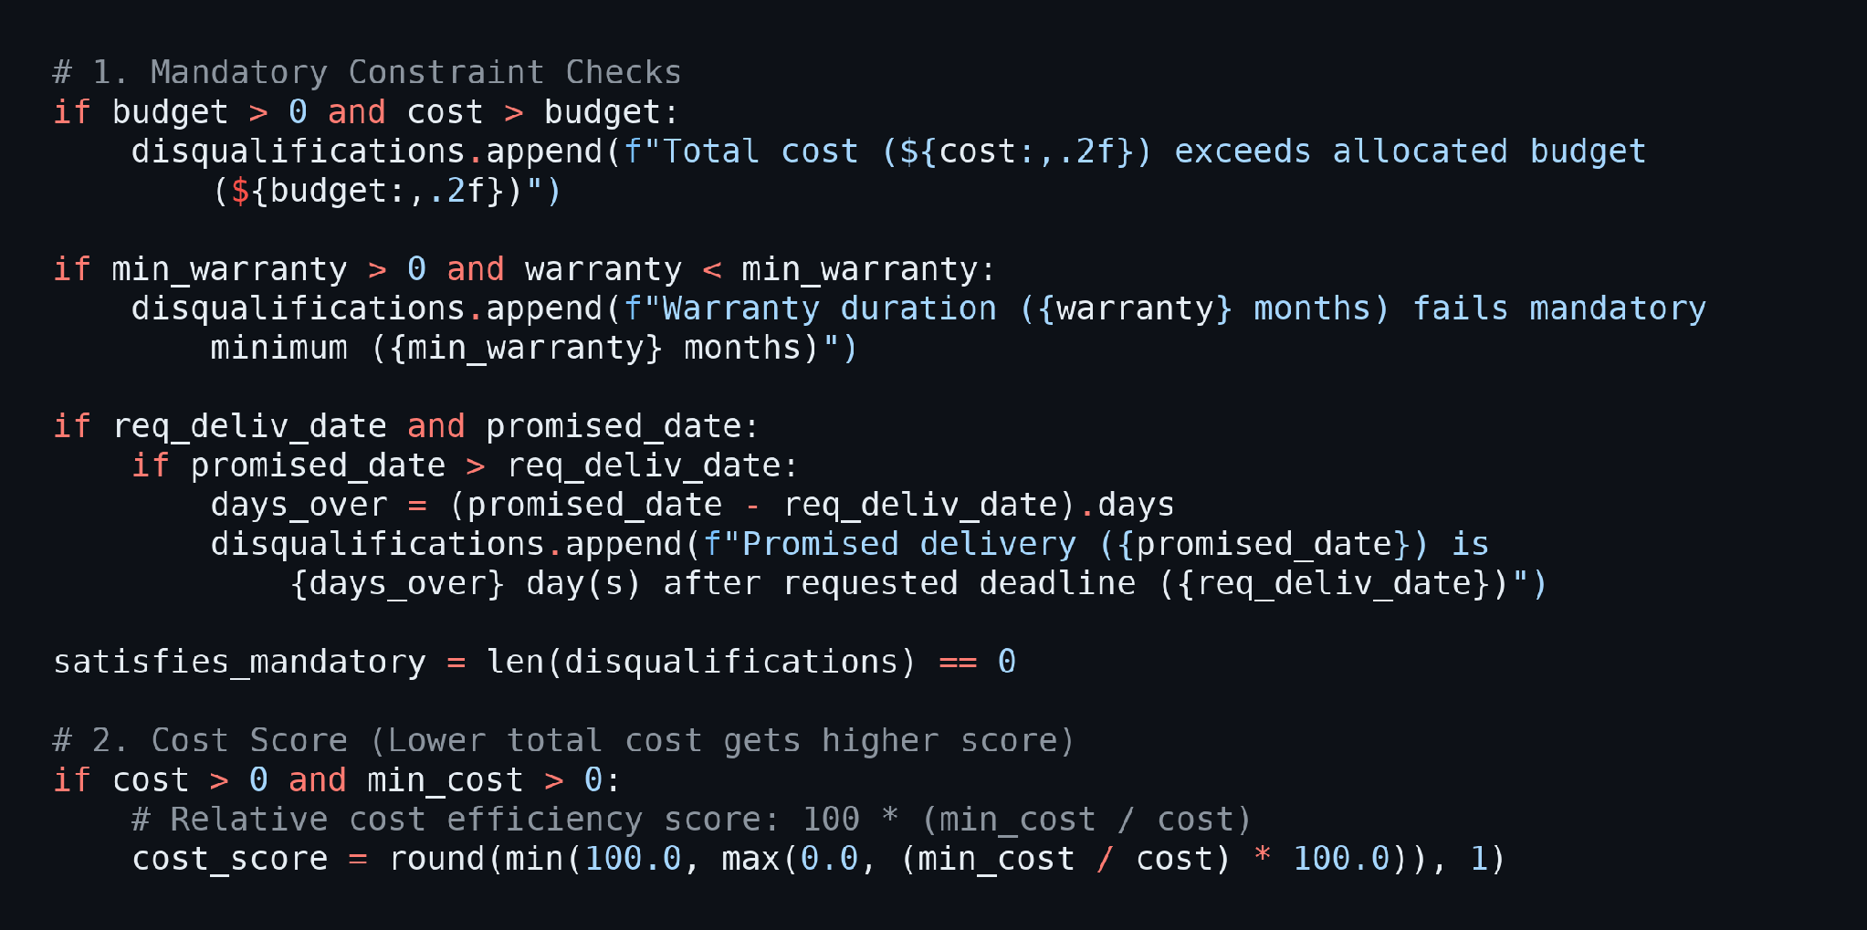
- Calculate the Overall Score and Rank: The four component scores are multiplied by their weights and added together. Eligible vendors are ranked first, then sorted by overall score, and the best eligible vendor is flagged as recommended.
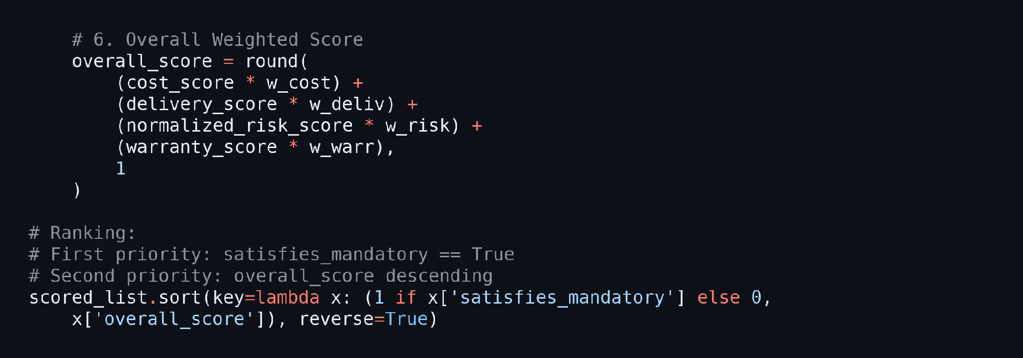
Implement the Landed Cost Calculator:
- Calculate Exact Costs: services/cost_calculator.py keeps arithmetic strictly separate from the language model. It computes the subtotal, the net subtotal after discount, the tax, and the total landed cost, and records the formula used.
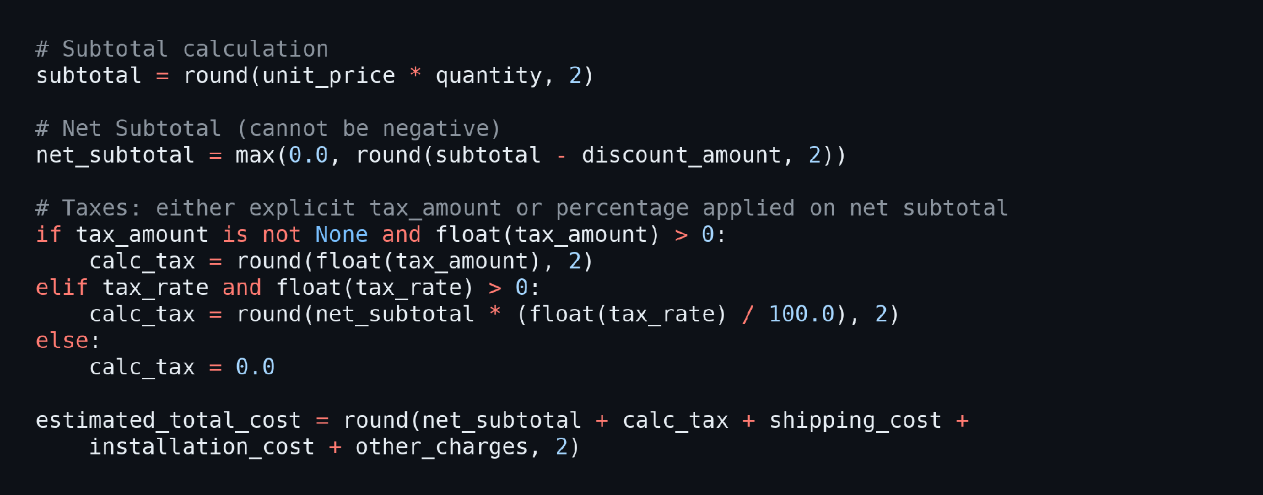

Activity 2.2: Implement the Flask Backend
Define the Database Layer:
- Open and Close Connections: database/db.py opens one SQLite connection per request, turns on foreign keys, and closes it automatically when the request ends.
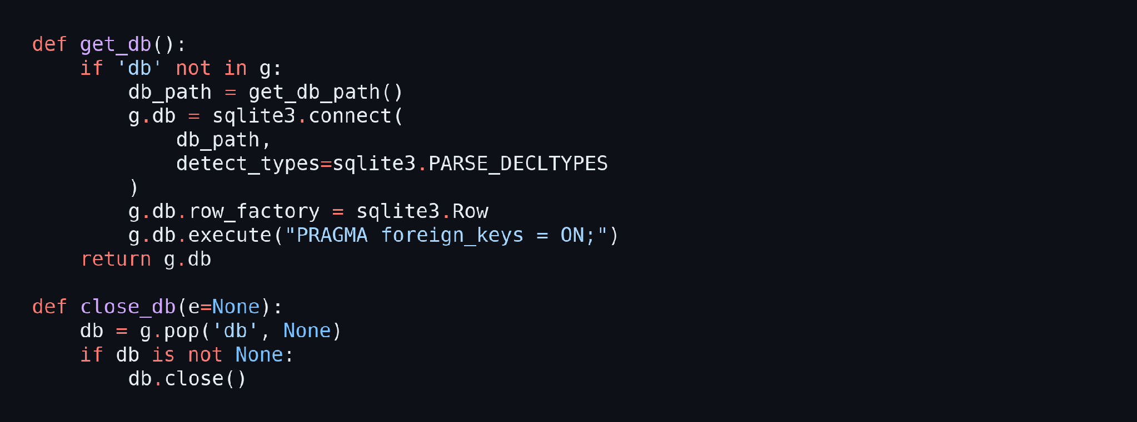
- Store Agent Runs and Outputs: schema.sql defines the agent_runs and agent_outputs tables that record every run, its execution mode, and the JSON output of each step.
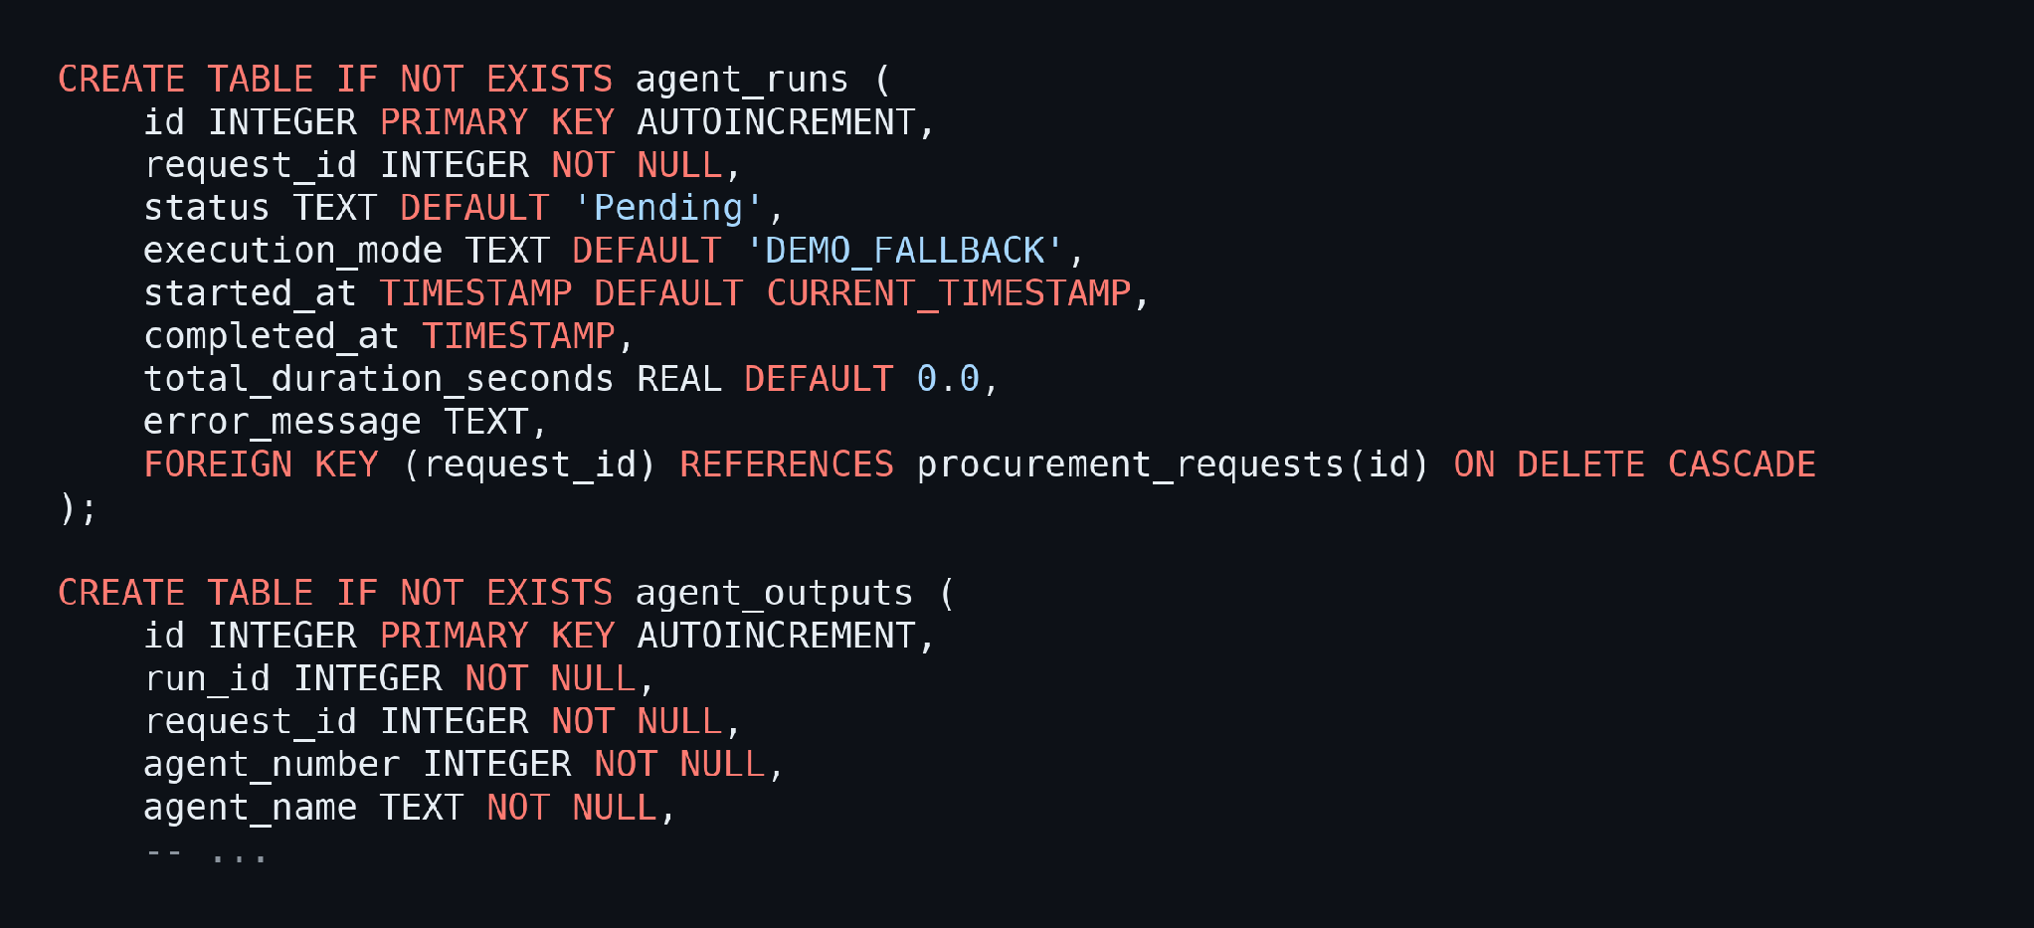
Process Quotation Uploads:
- Accept PDF, XLSX, XLS, and CSV files up to 16 MB, then extract the supplier name, prices, taxes, shipping, warranty, delivery time, and payment terms with PyMuPDF, openpyxl, and the csv module.
- Show the extracted values with an extraction-confidence percentage on an editable review page so that the buyer can correct them before running the agents.
- Offer a one-click option that loads three realistic sample quotations (a PDF, an Excel sheet, and a CSV file) for testing.
Run the Agents Step by Step:
- Validate the Prerequisites: Before a step runs, the orchestrator confirms that the earlier steps are complete, for example that Step 4 needs the output of Step 3.
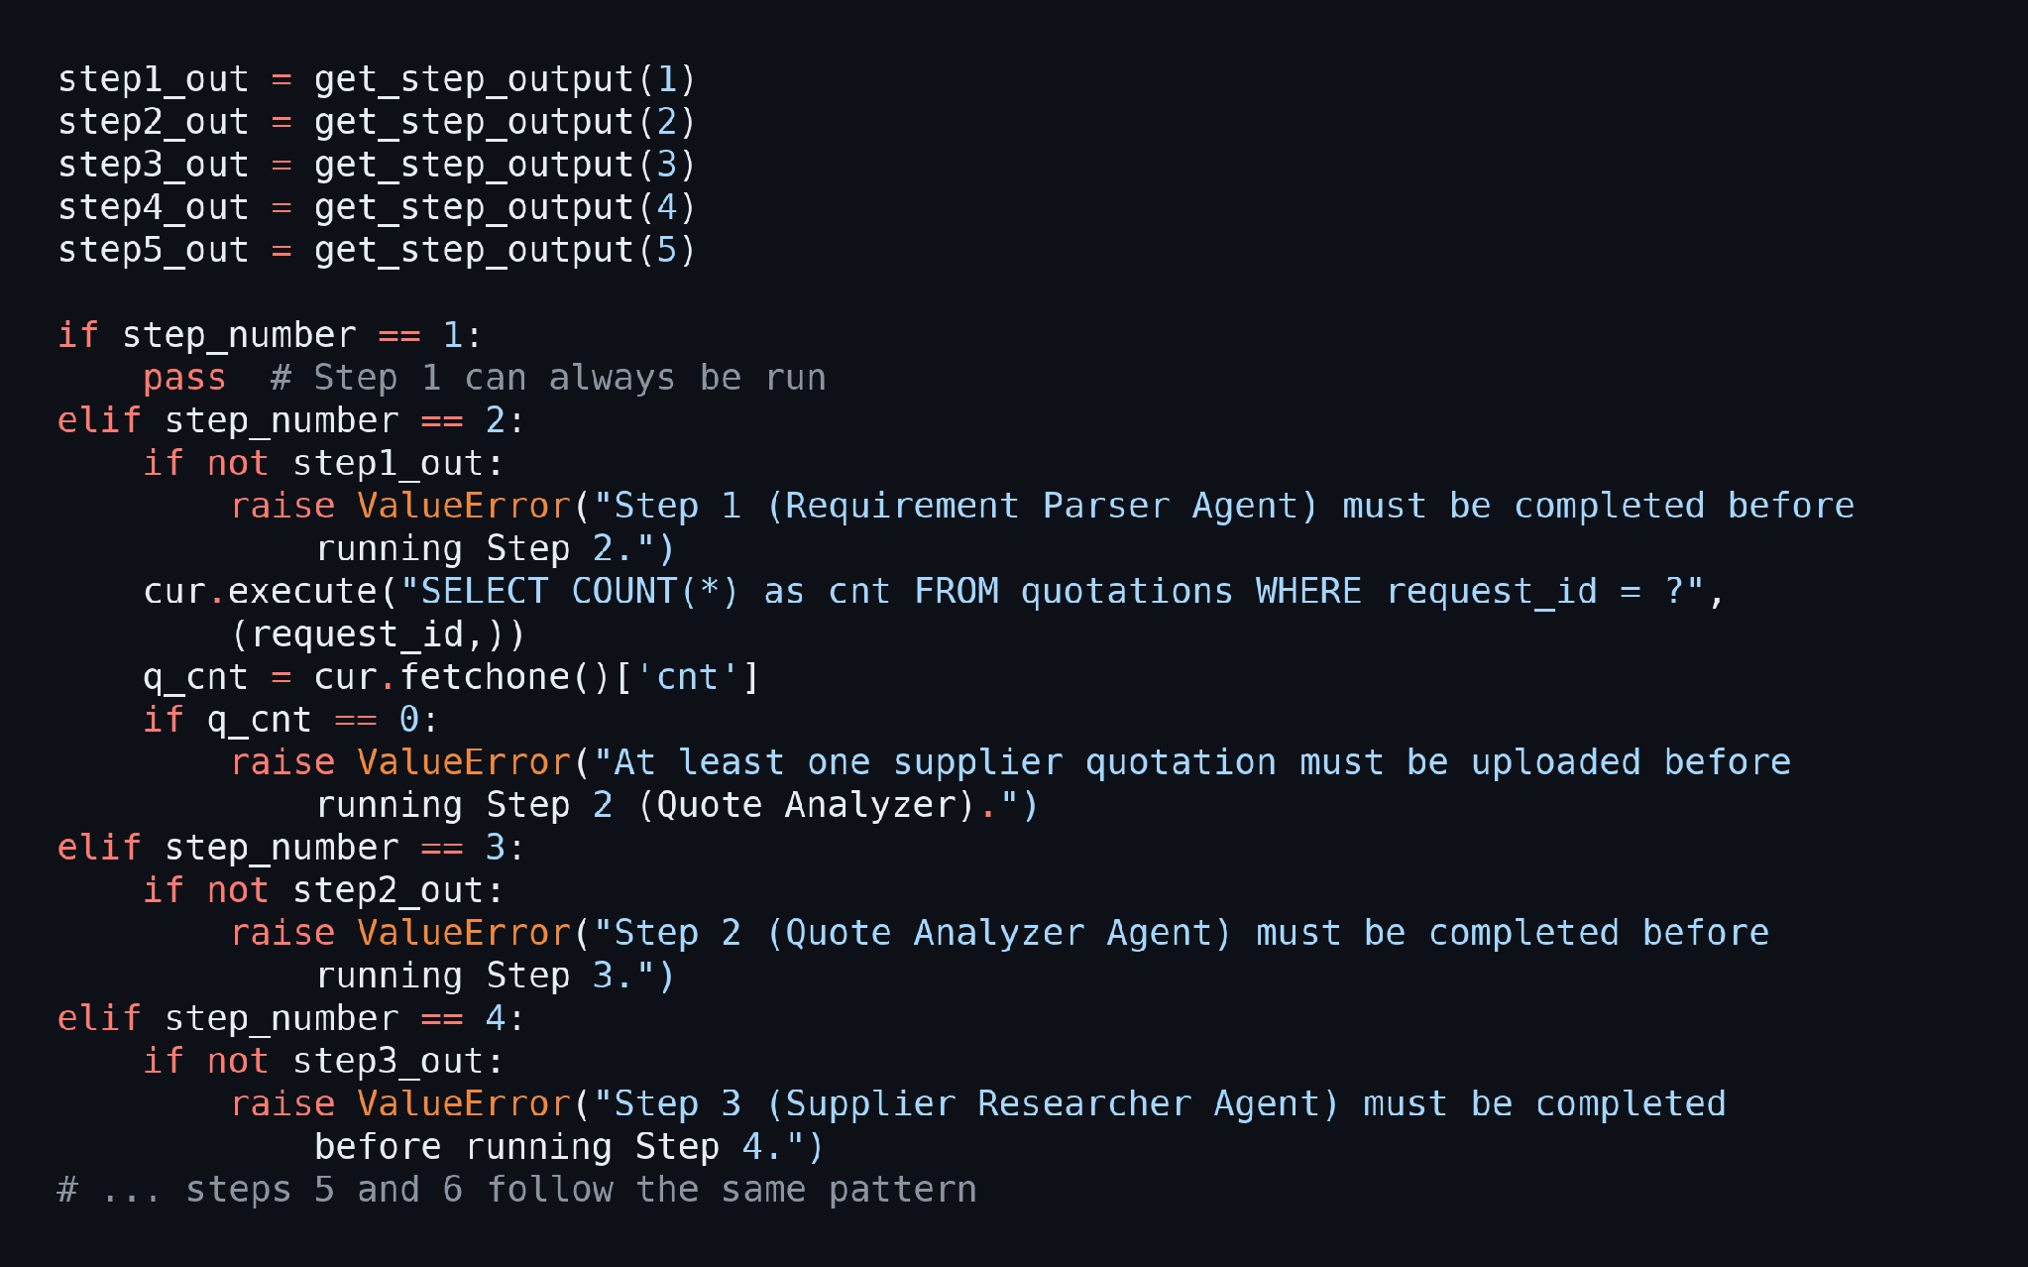
- Invalidate Stale Results and Execute One Step: When an earlier step is re-run, the results that depend on it are deleted, and then only the requested agent is executed.
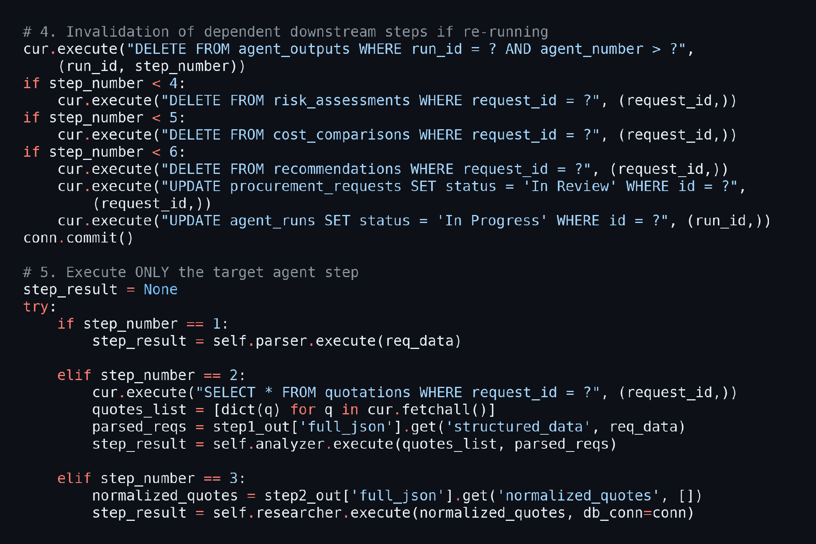
Integrate the Gemini API:
- Request Strict JSON: The helper sends the prompt to Gemini, asks for raw JSON, removes any markdown fences, and parses the result. If anything fails, it logs a warning and returns None so that the local engine is used instead.
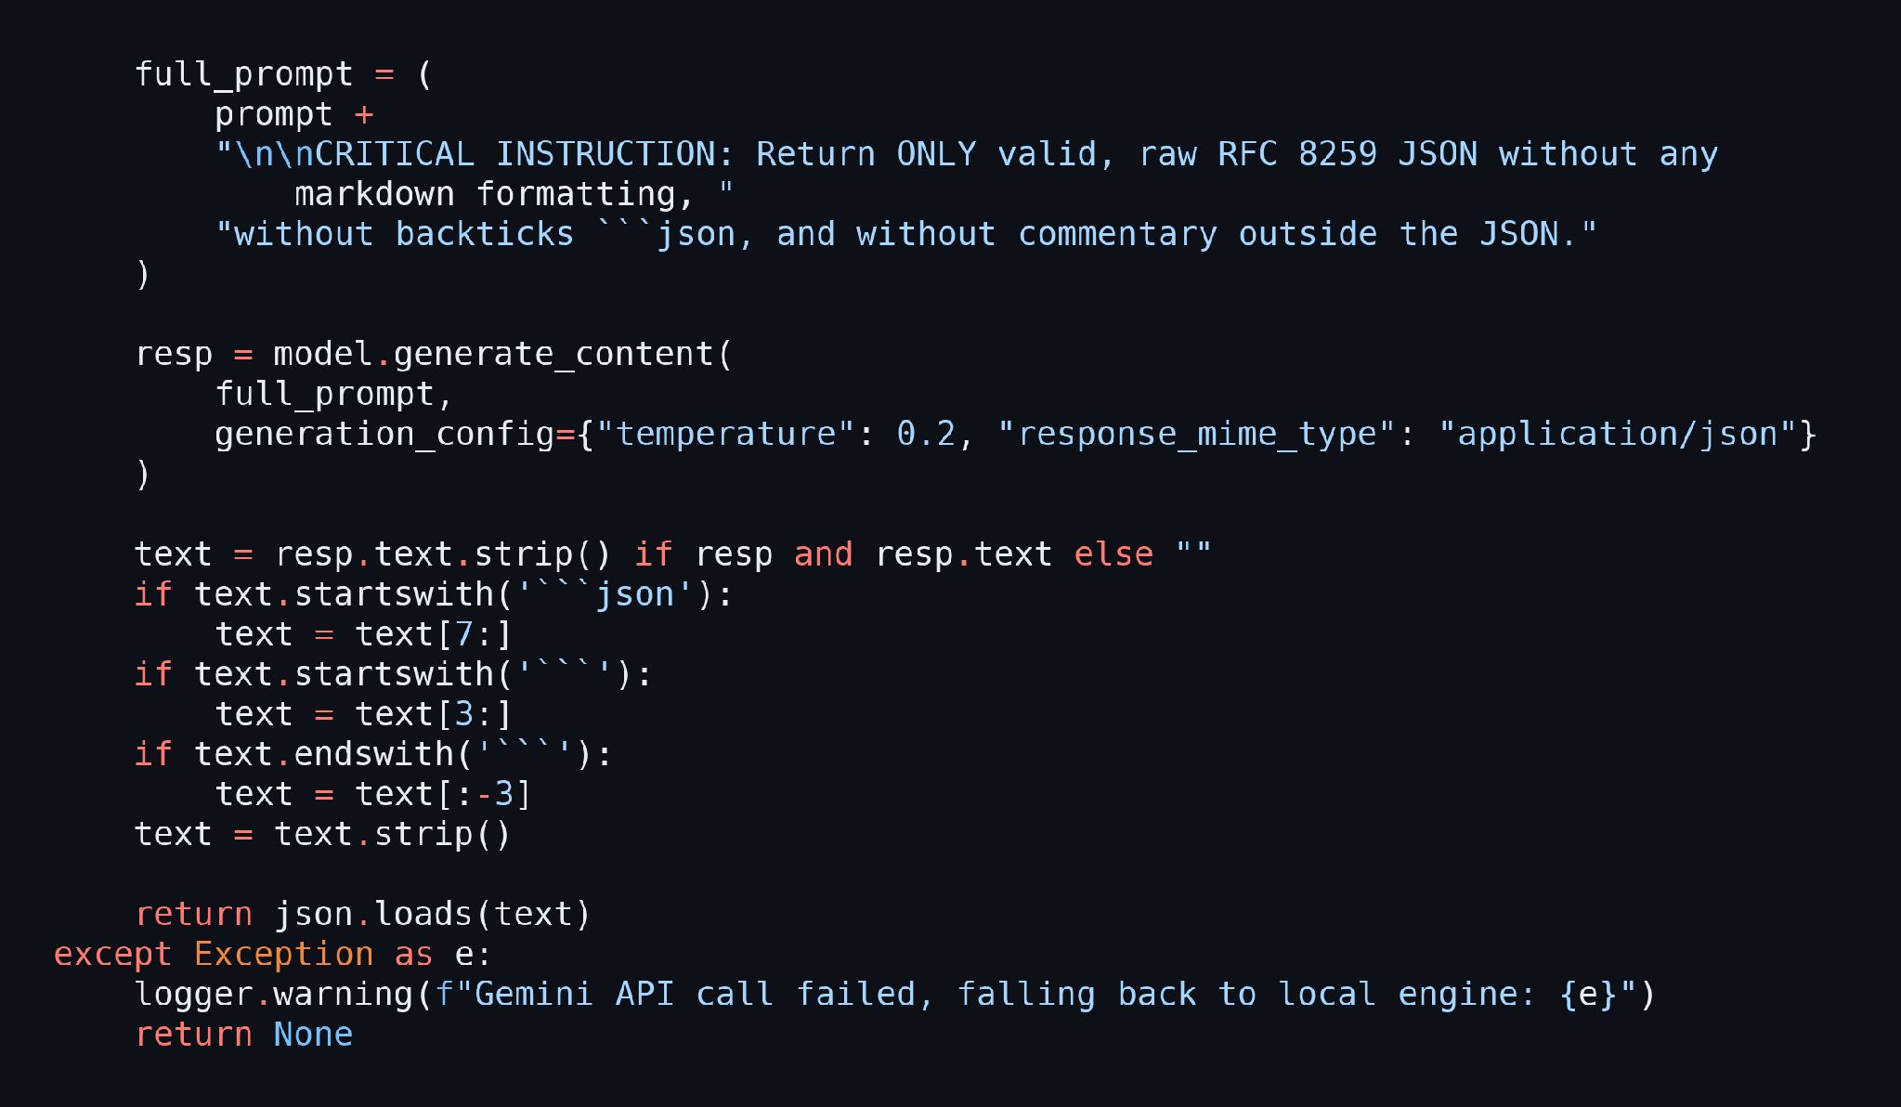
Secure the Routes:
- The login_required decorator protects every page and redirects visitors who are not signed in.
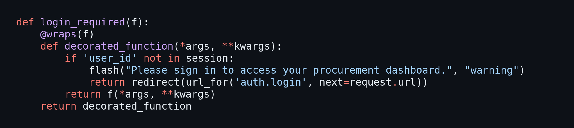
- The login route checks the password hash with Werkzeug and stores the user details in the Flask session.
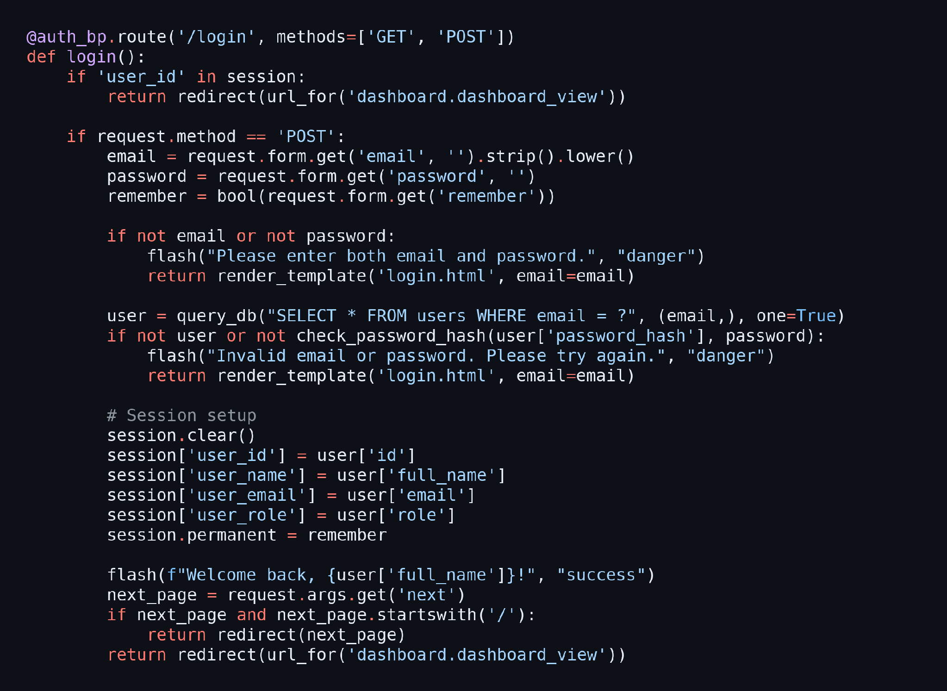

Milestone 3: App.py Development
Milestone 3 focuses on creating and refining the core logic of the app.py file, which serves as the backbone of the ProcurementIQ AI application. In this milestone, you will set up the application factory, register all route blueprints, and connect the agent workflow, the Gemini enrichment, and the report downloads.

Activity 3.1: Writing the Main Application Logic in app.py
Define the Application Factory:
- Import Flask, the Config class, the database helpers, the sample-data generator, and every blueprint module.
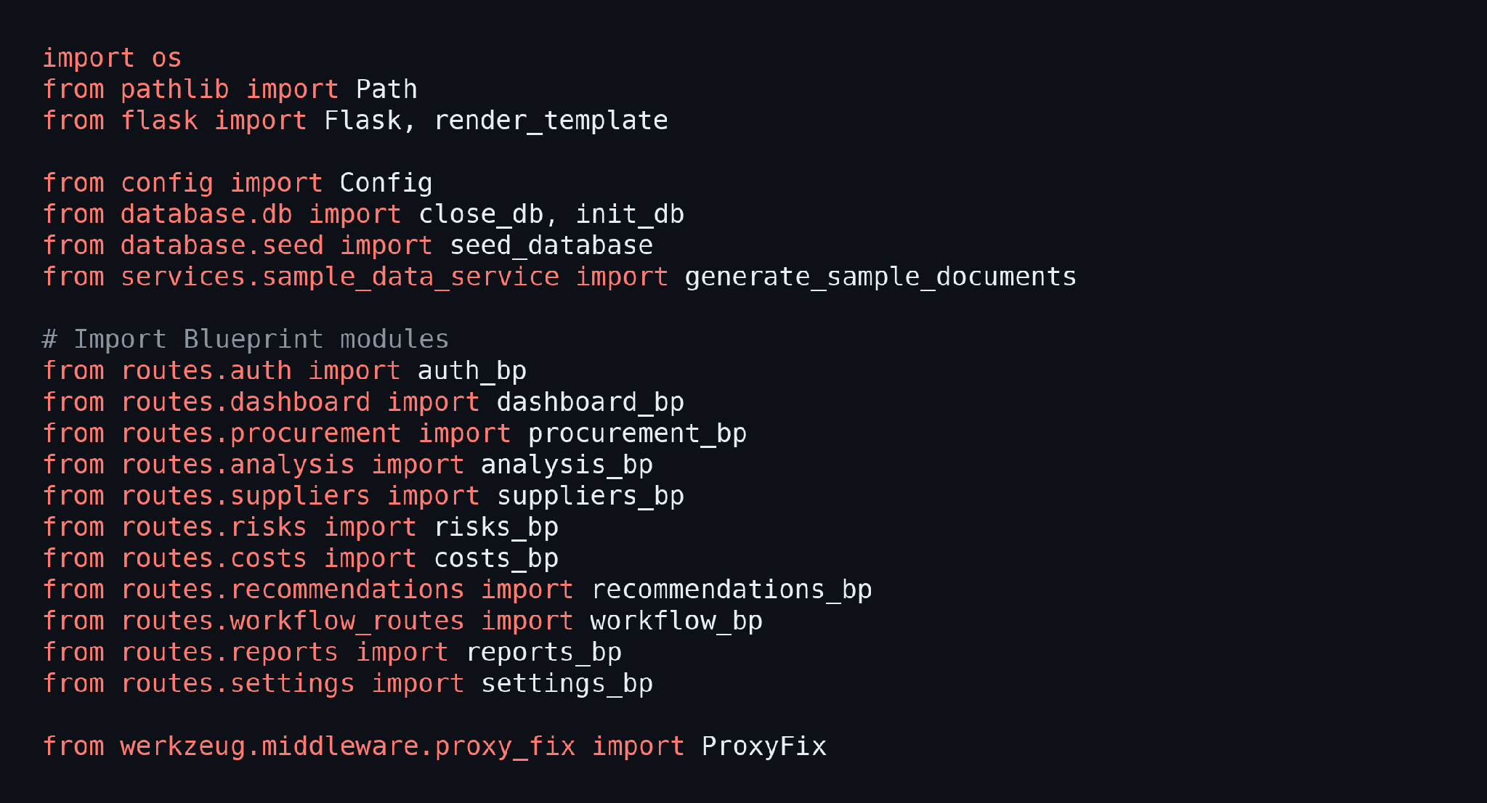
- Create the Flask app inside create_app(), load the configuration, enable ProxyFix for the Ngrok tunnel, create the upload and database folders, and initialize and seed the SQLite database without wiping user data.
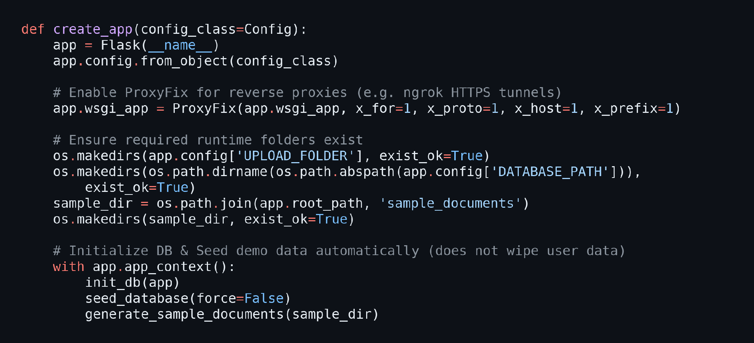
Inject Shared Template Variables:
- A context processor tells every template whether the Gemini and Ngrok keys are configured, and an after_request hook adds the header that bypasses the Ngrok browser warning.
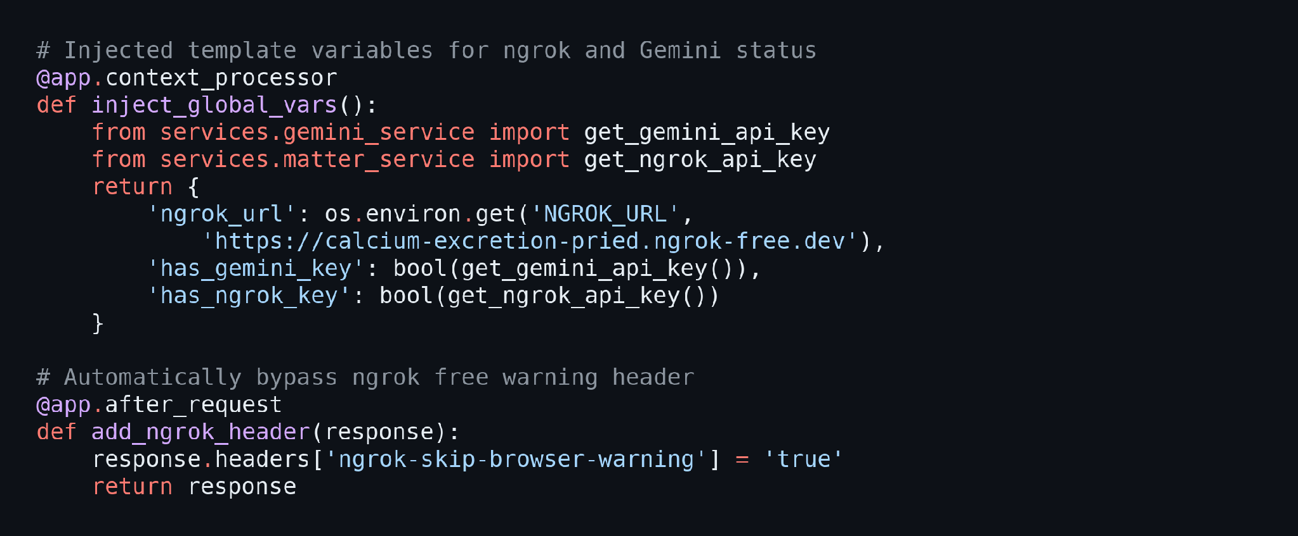
Register the Blueprints and Error Handlers:
- Register the eleven blueprints and the custom 404 and 500 pages, then return the app.
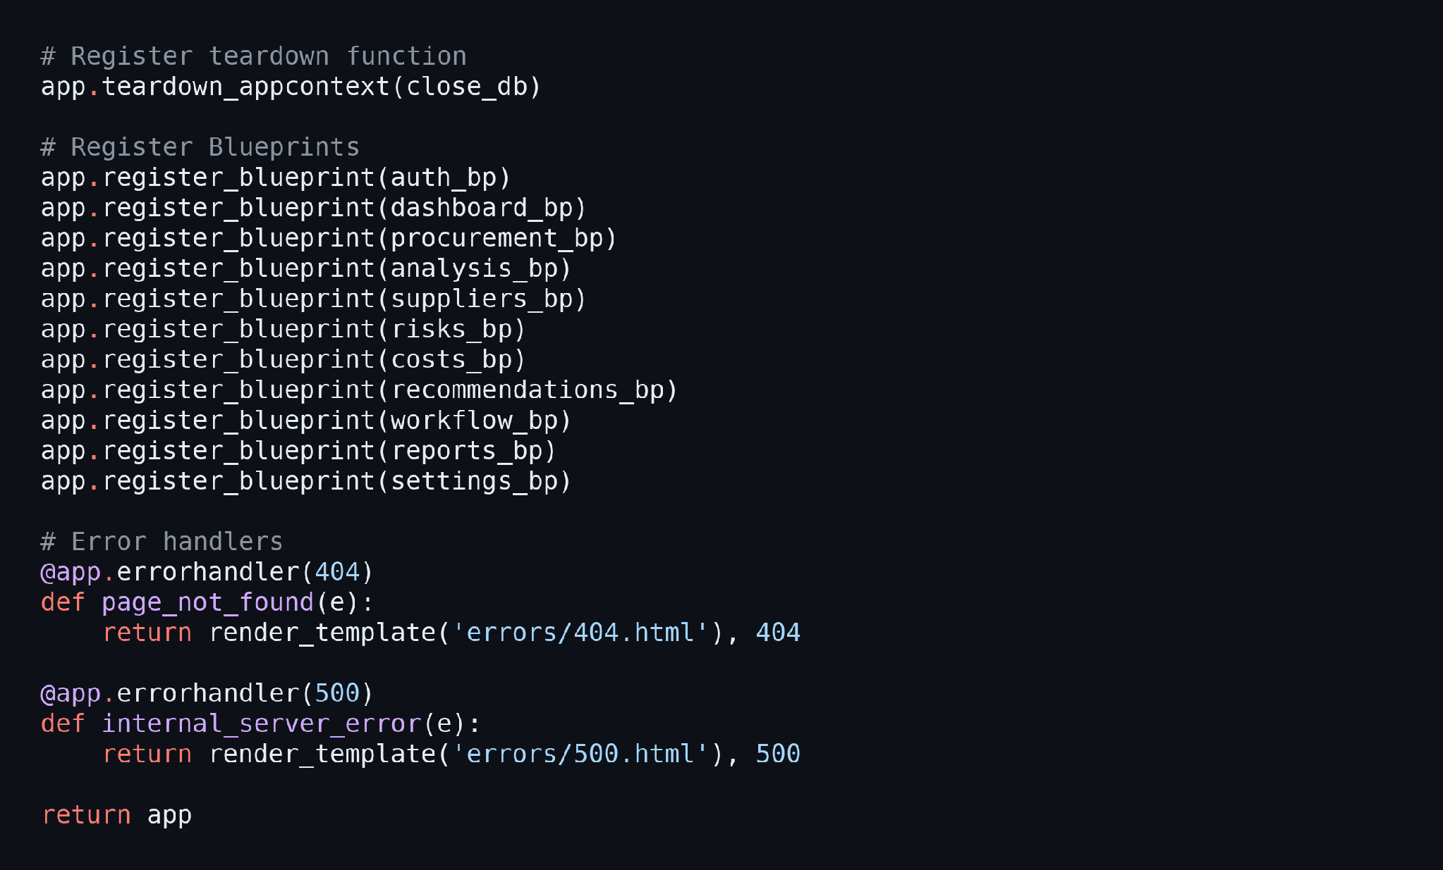
Define the Core Routes:
- / and /dashboard: The public landing page and the signed-in dashboard with KPI cards and charts.
- /signup, /login, and /logout: Account creation, authentication, and session handling.
- /requests/new and /requests/<id>: Create a procurement request and upload supplier quotations.
- /analysis/<id>: Review and edit the extracted quotation data.
- /agent-workflow/<id>: Run and view the six agents one step at a time and record the human decision.
- /suppliers, /risks, /costs, and /recommendations: Supplier research, risk assessment, cost optimization, and vendor recommendations.
- /reports and /settings: Executive PDF and CSV downloads, scoring weights, currency, and API key tests.
Run an Agent Step and Record the Decision:
- The run-step route loads the saved weights, calls the orchestrator for the selected step, and shows the result or the reason it was halted.
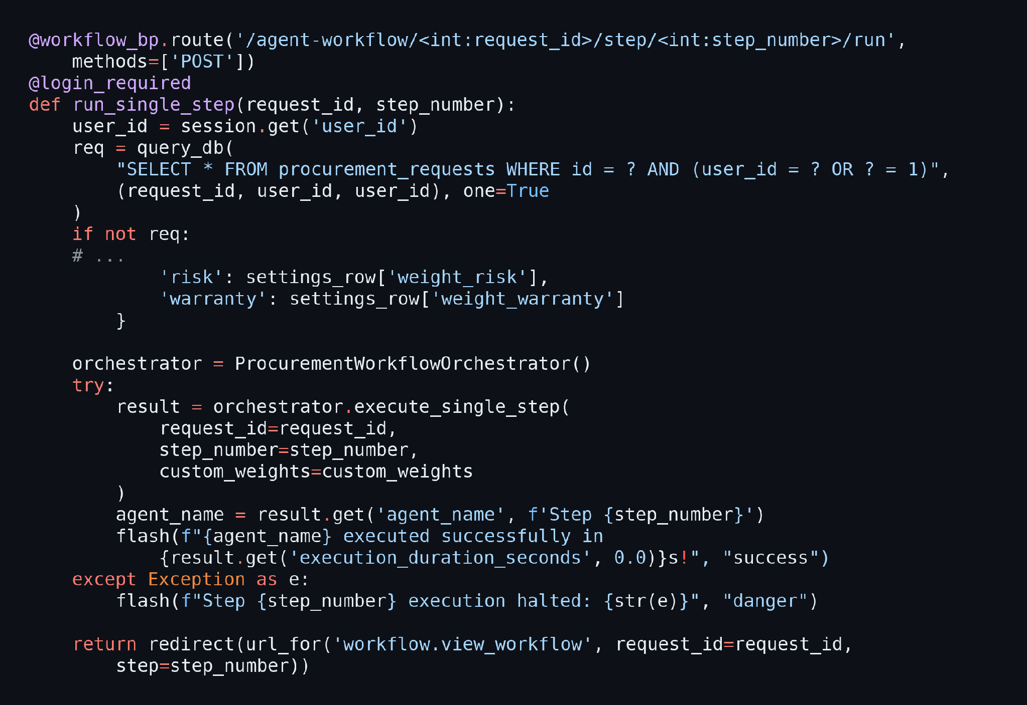
- The decision route saves the buyer’s approval, alternative supplier, or rejection in decision_history and marks the request as Completed.
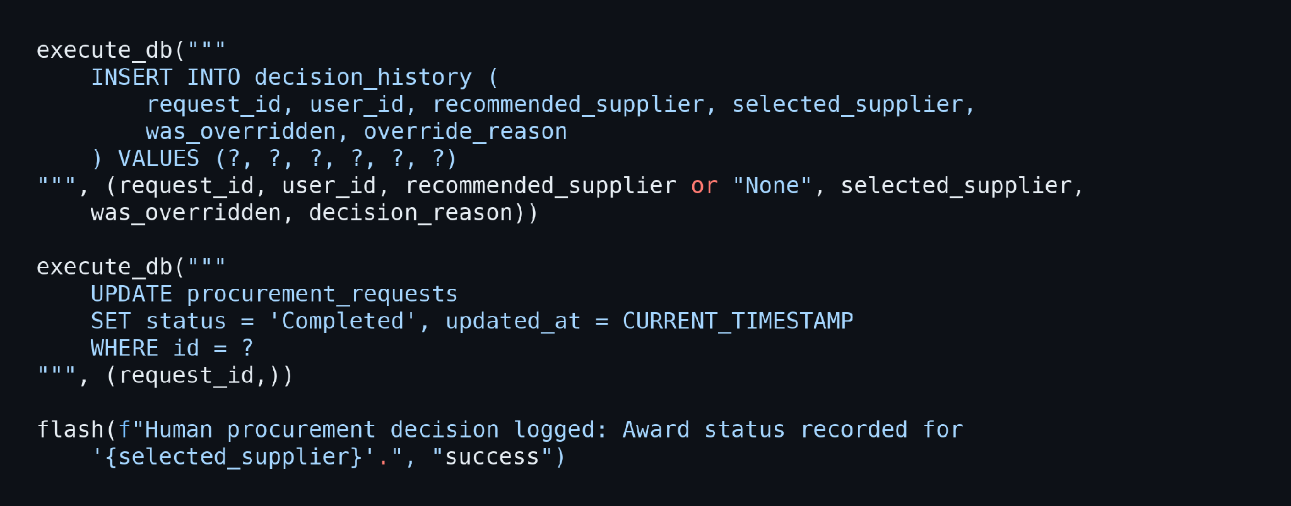
Start the Server:
- Create the app instance and, when app.py is run directly, print the start-up banner and launch the Flask server.
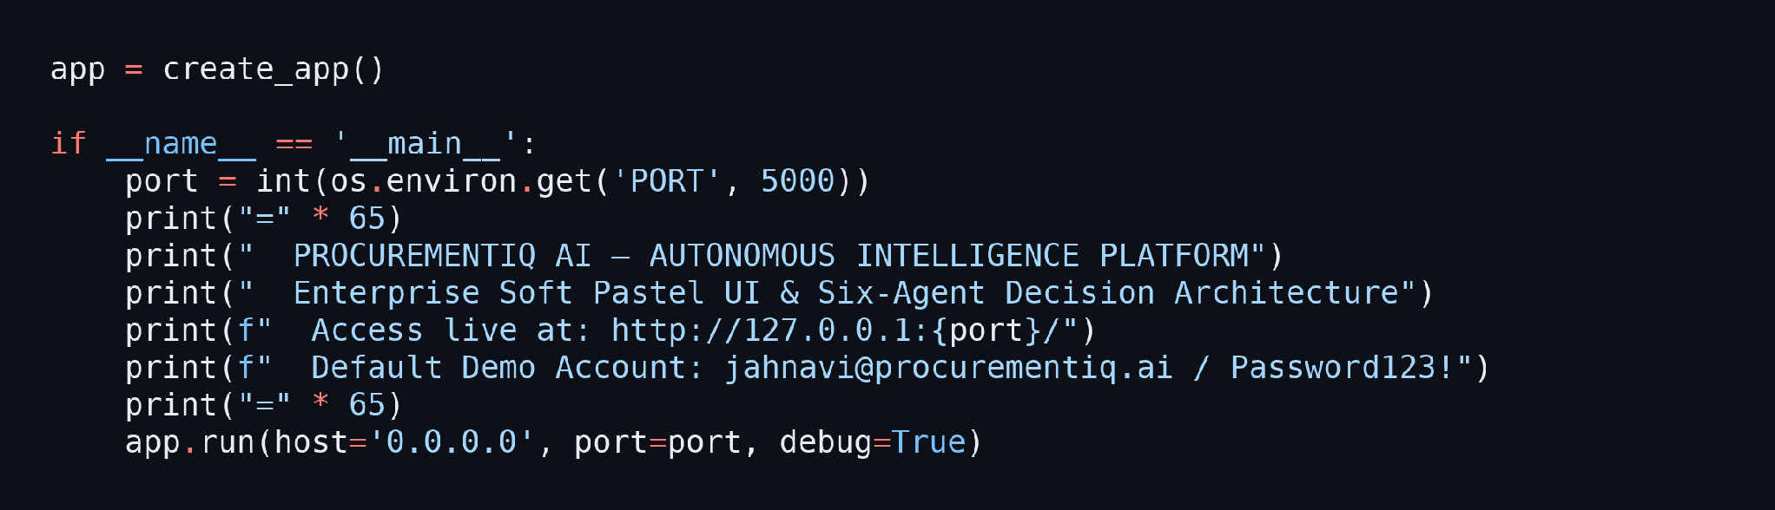

Milestone 4: Frontend Development
Milestone 4 focuses on developing a clean, professional interface for ProcurementIQ AI. This involves building the pages with Jinja2 templates, styling them with a soft pastel enterprise design system, and adding charts and small interactions with Chart.js and vanilla JavaScript.

Activity 4.1: Designing and Developing the User Interface
Set Up the Base Template:
- base.html defines the sidebar navigation, the top search bar, the flash-message area, and the page content block that every signed-in page extends. The active menu item is highlighted by checking request.endpoint.
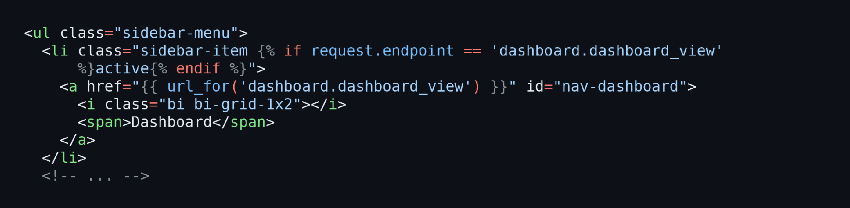
Create the Pastel Enterprise Design System:
- static/css/style.css defines the colour palette, radii, and shadows as CSS variables (pastel blue, lavender, peach, mint, and dark navy), and dashboard.css and auth.css add the page-specific layouts.
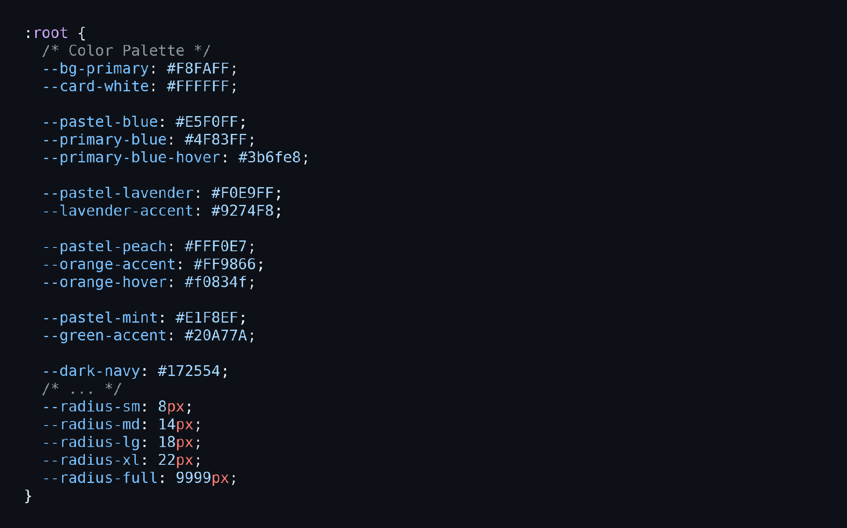
Build the Page Templates:
- Public Pages: landing.html, login.html, and signup.html present the product and handle authentication.
- Workspace Pages: dashboard.html, new_request.html, request_detail.html, and quotation_analysis.html guide the buyer from request creation to quotation review.
- Agent and Decision Pages: agent_workflow.html, suppliers.html, risks.html, cost_optimization.html, and recommendations.html show the output of each agent and the final ranking.
- Admin Pages: reports.html, settings.html, and the error pages complete the application.
Design a Responsive Layout:
- Use CSS grid and flexbox with media queries so that the sidebar becomes an off-canvas drawer on tablets and phones.

Activity 4.2: Creating Dynamic Interactions with JavaScript
Add Lightweight Client-Side Behaviour:
- static/js/app.js adds the password visibility toggle, dismissible alerts, and the sidebar drawer, using only vanilla JavaScript.
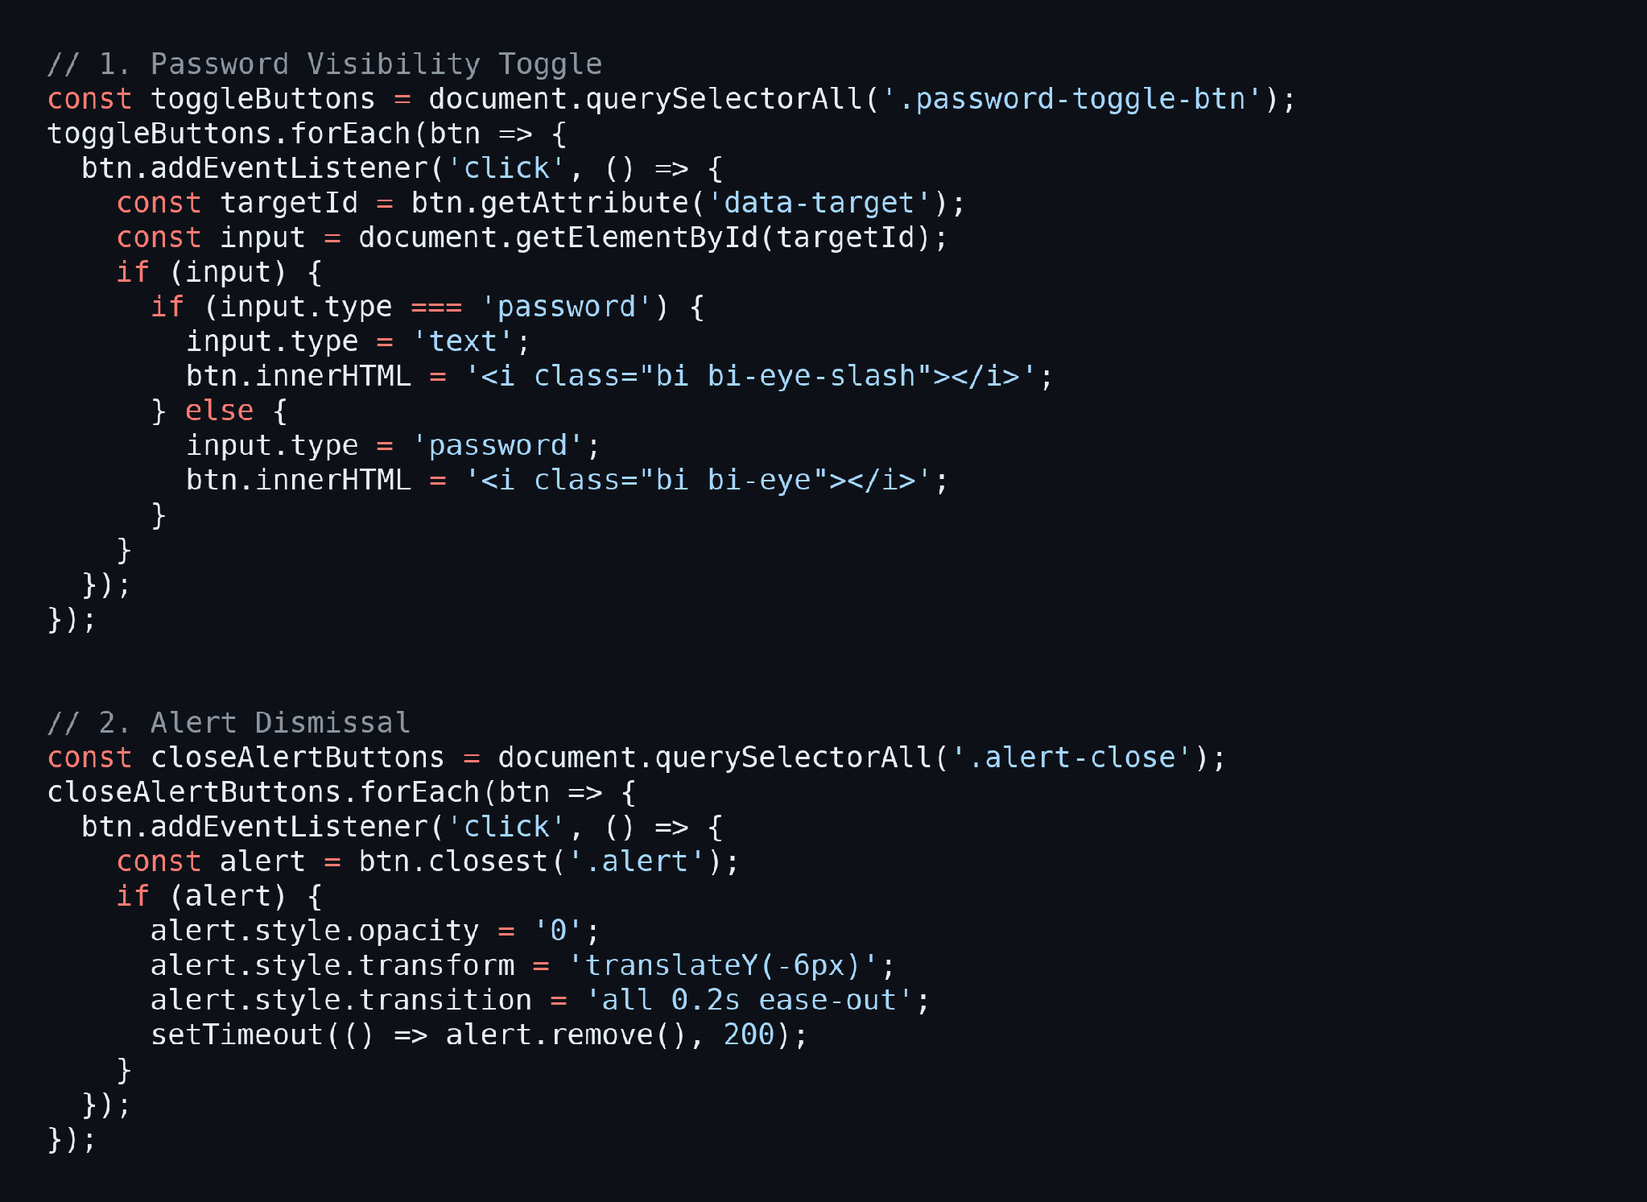
Render Charts:
- The dashboard, risk assessment, cost optimization, and agent workflow pages use Chart.js to draw the cost comparison, risk distribution, and landed-cost composition charts from the data that the server passes to the template.

Milestone 5: Deployment
In Milestone 5, the focus is on deploying the ProcurementIQ AI application first locally to verify correct operation, and then publicly via Ngrok to share the app with others through a secure URL. This involves configuring the server environment, managing dependencies, and launching the app for real-world use.

Activity 5.1: Preparing the Application for Local Deployment
Set Up a Virtual Environment:
- Create and activate a virtual environment, then install all required dependencies from requirements.txt:
python -m venv venv
source venv/bin/activate # For macOS/Linux
venv\Scripts\activate # For Windows
pip install -r requirements.txt
Configure Environment Variables:
- Copy .env.example to .env and set SECRET_KEY, DEMO_MODE, LLM_PROVIDER, and your Gemini key as described in Activity 1.1. The database and the uploads folder are created automatically on the first start.
cp .env.example .env

Activity 5.2: Local Testing and Verification
Start the Flask Development Server:
- Run the application locally using:
python app.py
- The terminal prints the start-up banner and the address of the server:
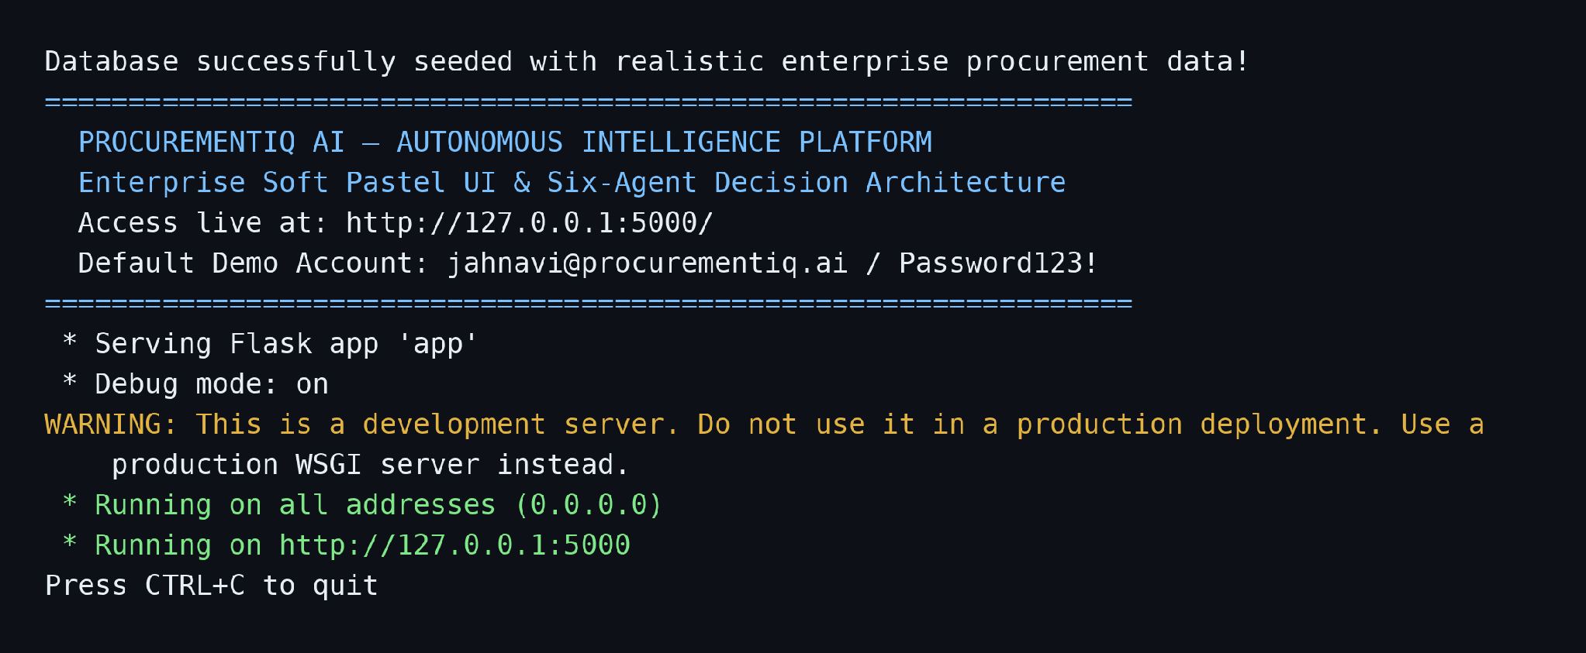
- Open a browser and go to http://127.0.0.1:5000. Sign in with the seeded demo account (jahnavi@procurementiq.ai / Password123!) or create a new account on the signup page.
- Create a request, load the sample quotations, confirm them, and run the six agents one by one. Then open Vendor Recommendations, record a decision, and download the PDF and CSV reports to verify the full flow.
Run the Automated Tests:
- The tests folder contains functional tests for the routes, the workflow, and the Gemini integration:
python tests/test_app.py

Activity 5.3: Public Deployment via Ngrok
Ngrok creates a secure tunnel from a public URL to your local Flask server, making the app accessible from anywhere without a cloud hosting provider. The application is already prepared for this: ProxyFix lets Flask trust the forwarded HTTPS headers, and the ngrok-skip-browser-warning header is added to every response.
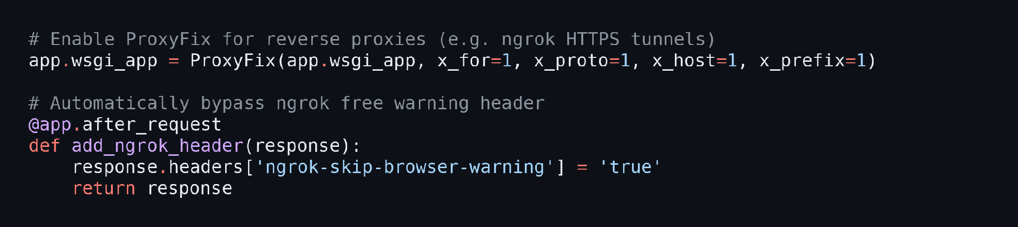
Install Ngrok:
- Download and install the Ngrok client from https://ngrok.com/download for your operating system.
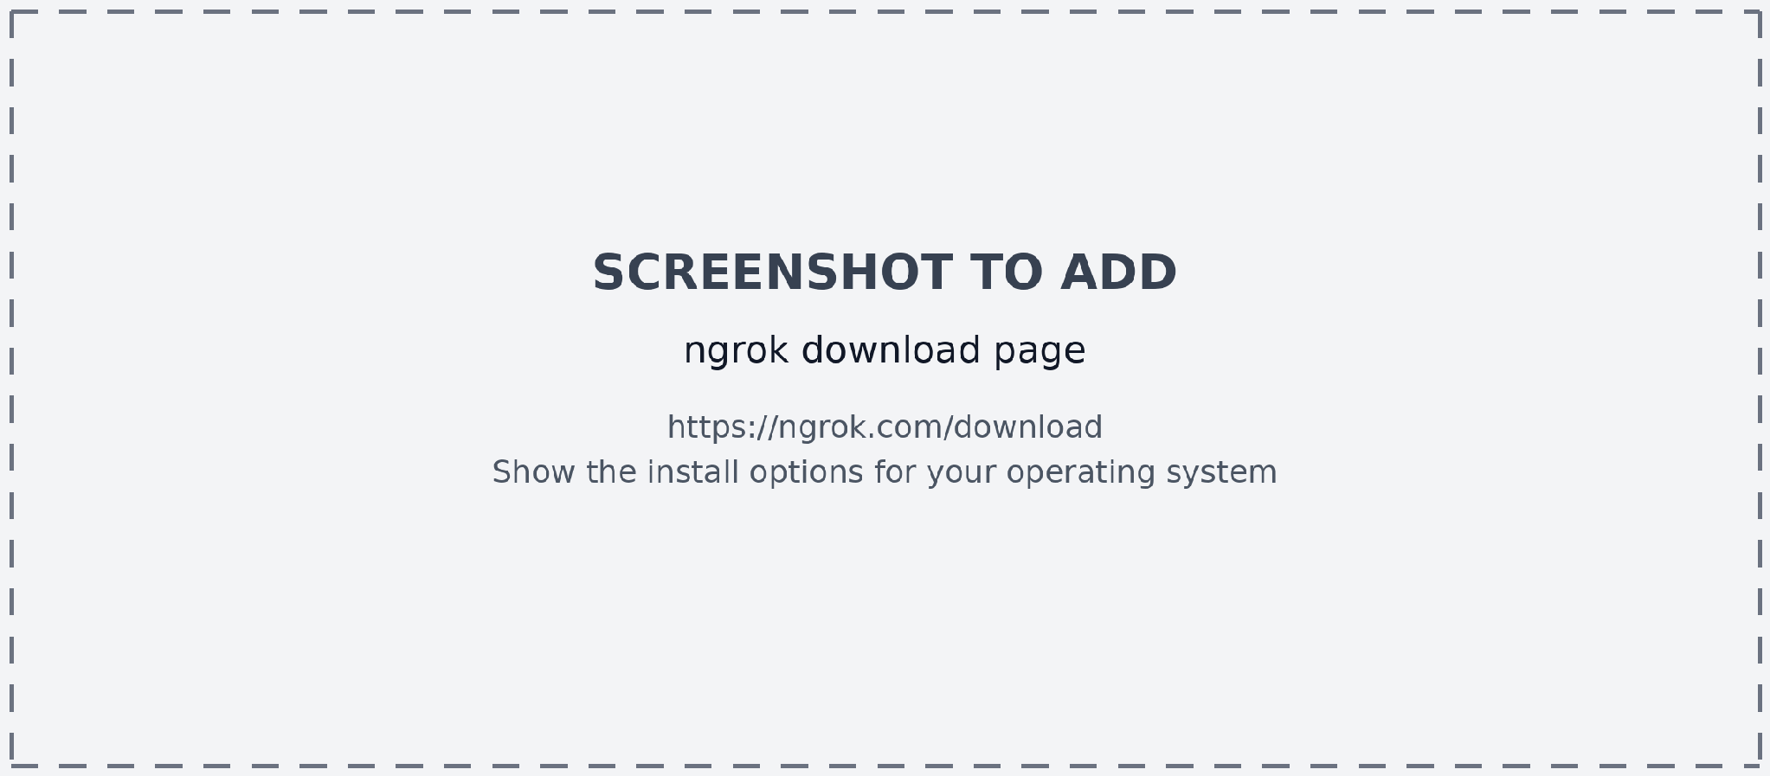
Configure Your Ngrok Authtoken:
- Sign up at ngrok.com, copy your authtoken from the dashboard, and register it once on your machine:
ngrok config add-authtoken YOUR_NGROK_AUTHTOKEN
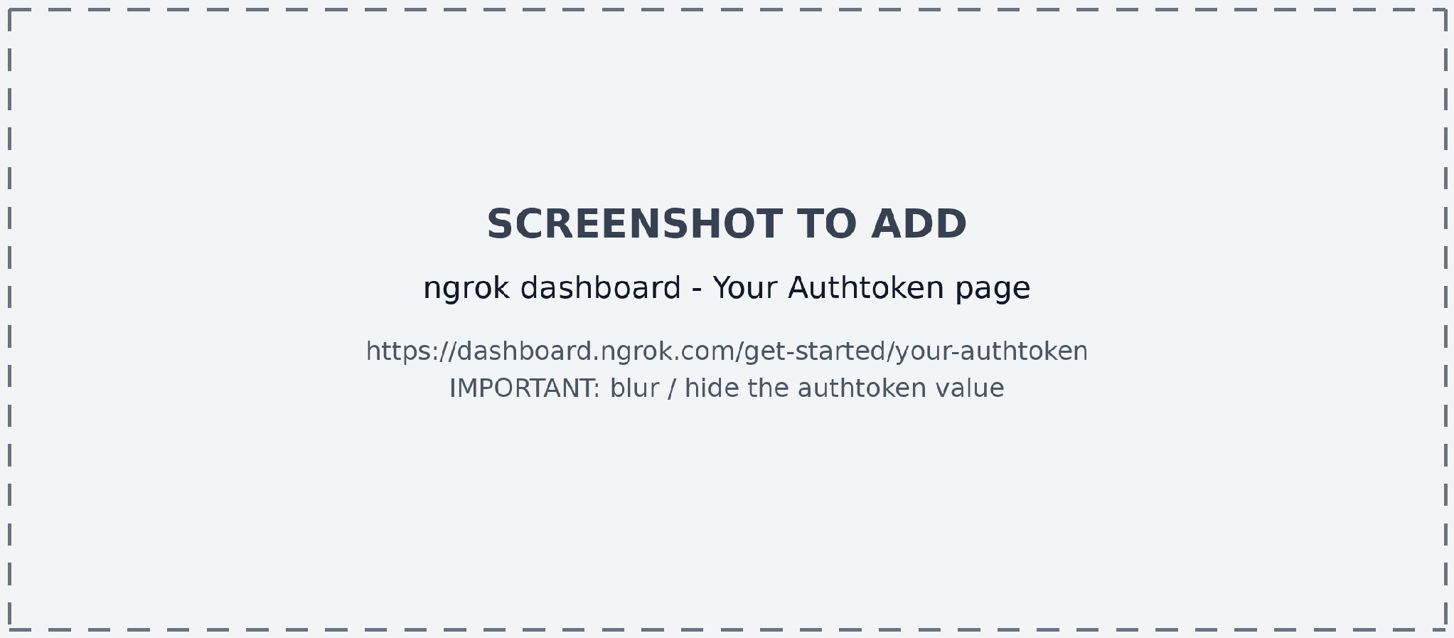
Expose the Flask Application:
- Keep python app.py running, open a second terminal, and start a tunnel to port 5000:
ngrok http 5000
- Ngrok prints a public forwarding address in the terminal. Optionally set it as NGROK_URL in the .env file so that the app can display it:
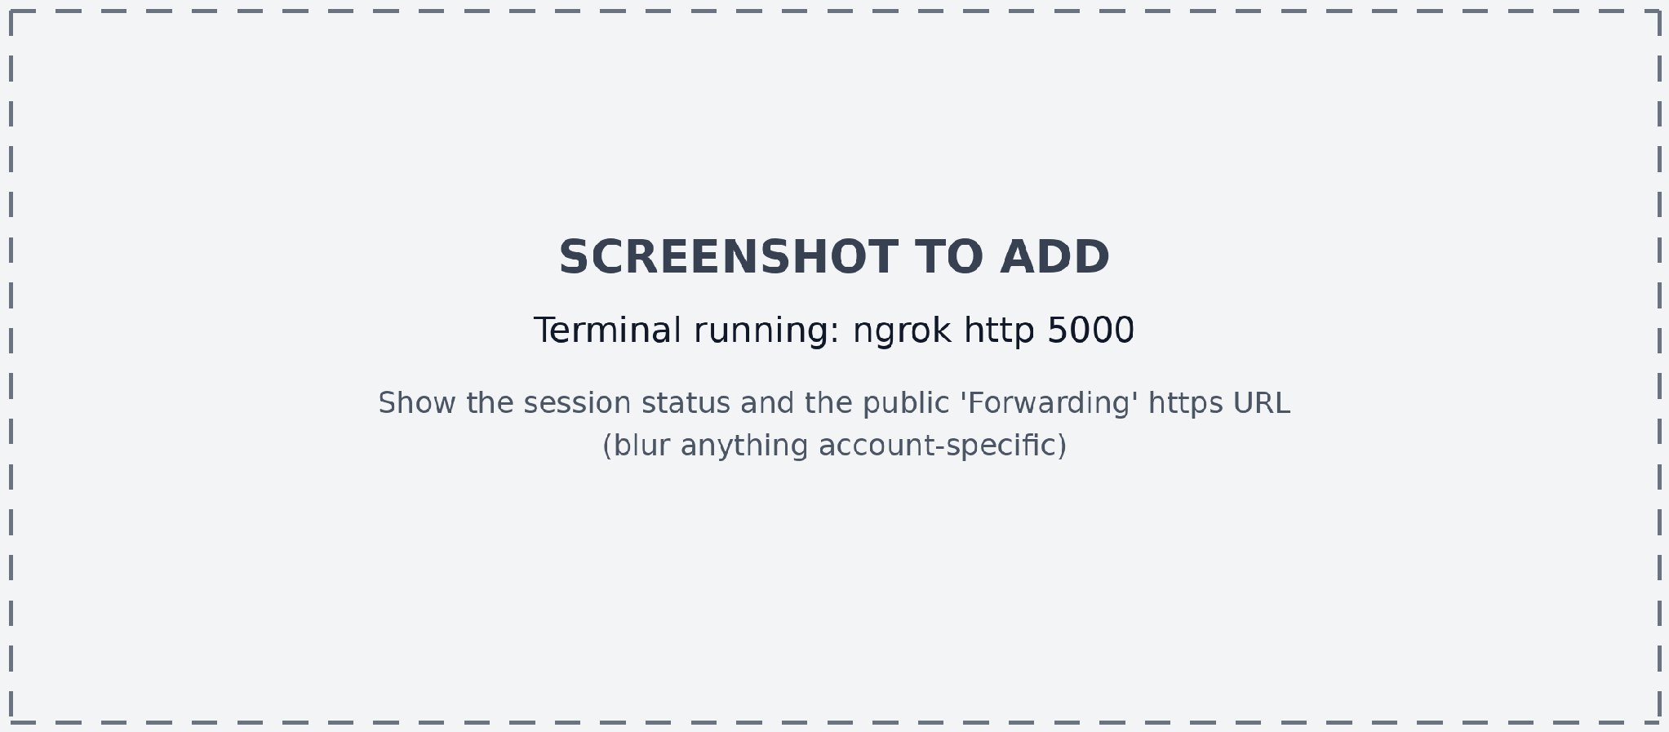
Forwarding https://xxxx-xx-xx-xxx-xx.ngrok-free.app -> http://localhost:5000
- Share this URL with anyone. They can open ProcurementIQ AI in their browser without installing anything.
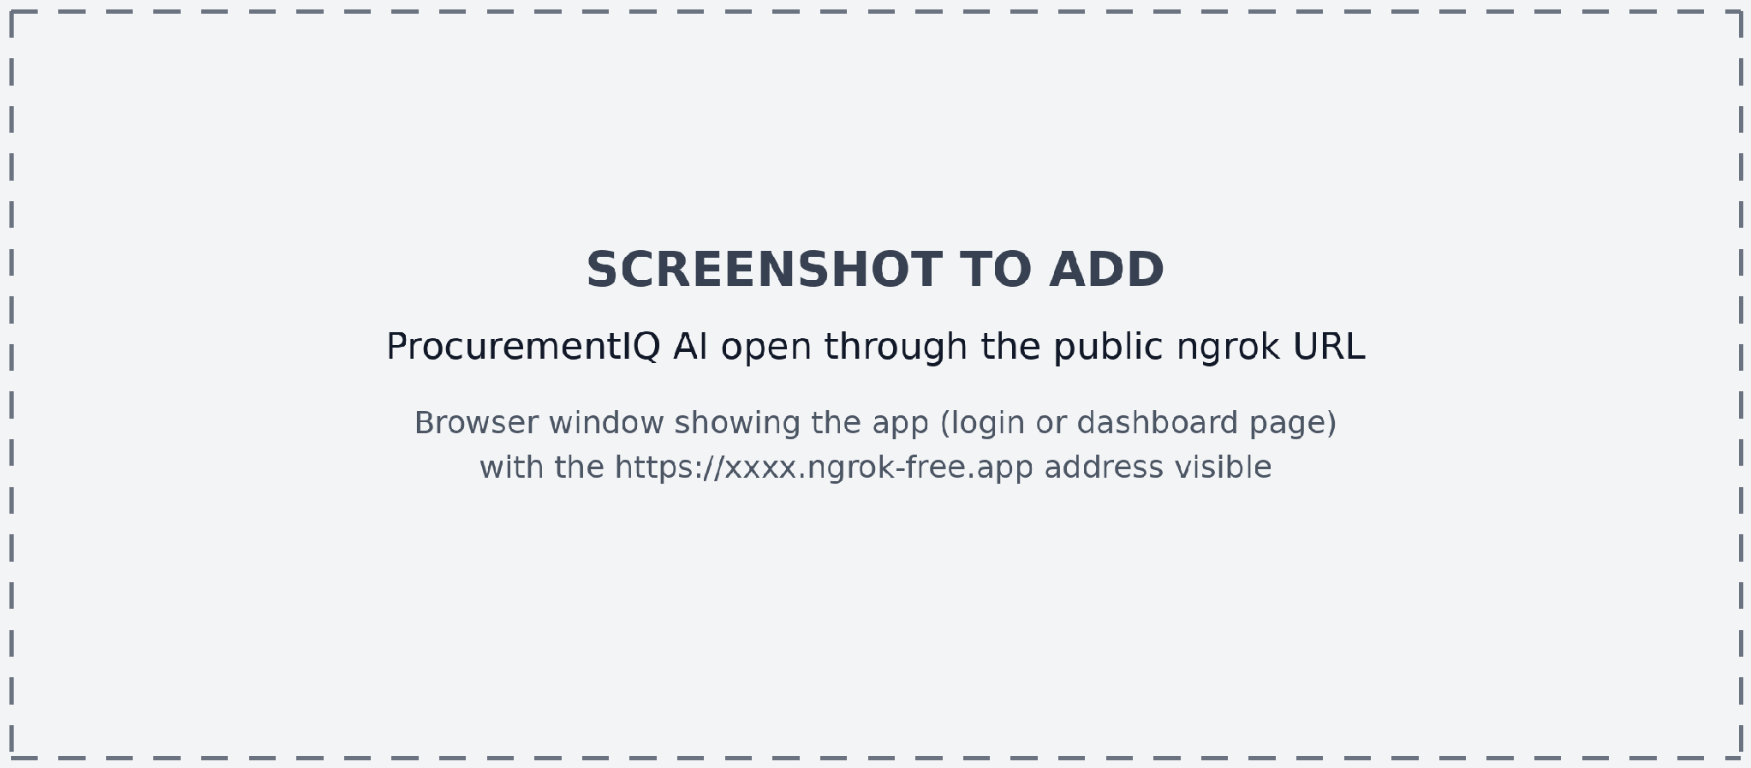
Important Notes:
- The public URL changes each time you restart the tunnel on the free Ngrok plan. For a persistent URL, reserve a domain in the Ngrok dashboard.
- app.py starts the server with debug=True for development. Turn debug mode off and use a production WSGI server before using the app outside demos.
- Never share your .env file, your Gemini key, or your Ngrok authtoken, and rotate them if they are ever exposed.
- In DEMO MODE the app needs no API key, so it can be shown publicly without spending any API quota.

Exploring the Website’s Web Pages:

Landing Page:
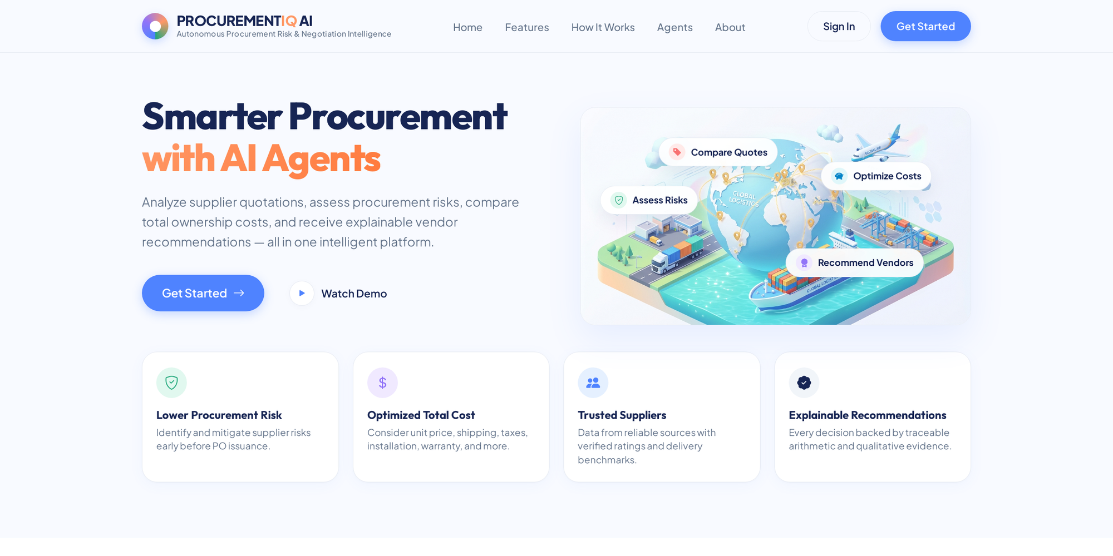
Description: The public home page introduces the platform with a hero section (“Smarter Procurement with AI Agents”), a top navigation bar, Sign in and Get Started buttons, and four feature highlights: lower procurement risk, optimized total cost, trusted suppliers, and explainable recommendations.

Sign Up Page:
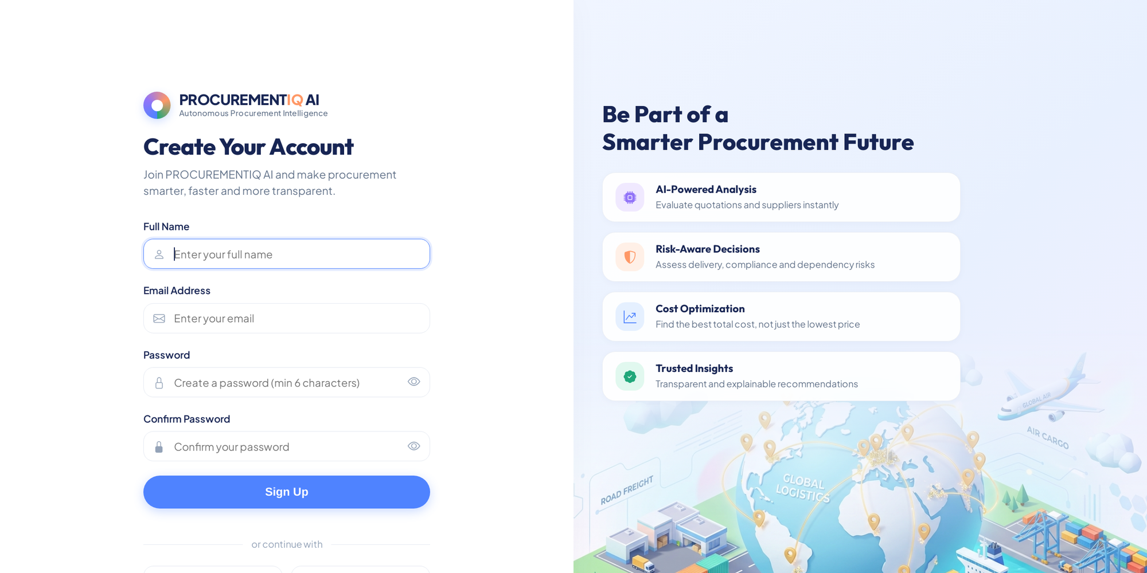
Description: New users create an account by entering their full name, email address, and a password of at least six characters that is confirmed a second time. Passwords are hashed with Werkzeug before they are stored in SQLite, and a feature panel on the right explains the benefits of the platform.

Login Page:
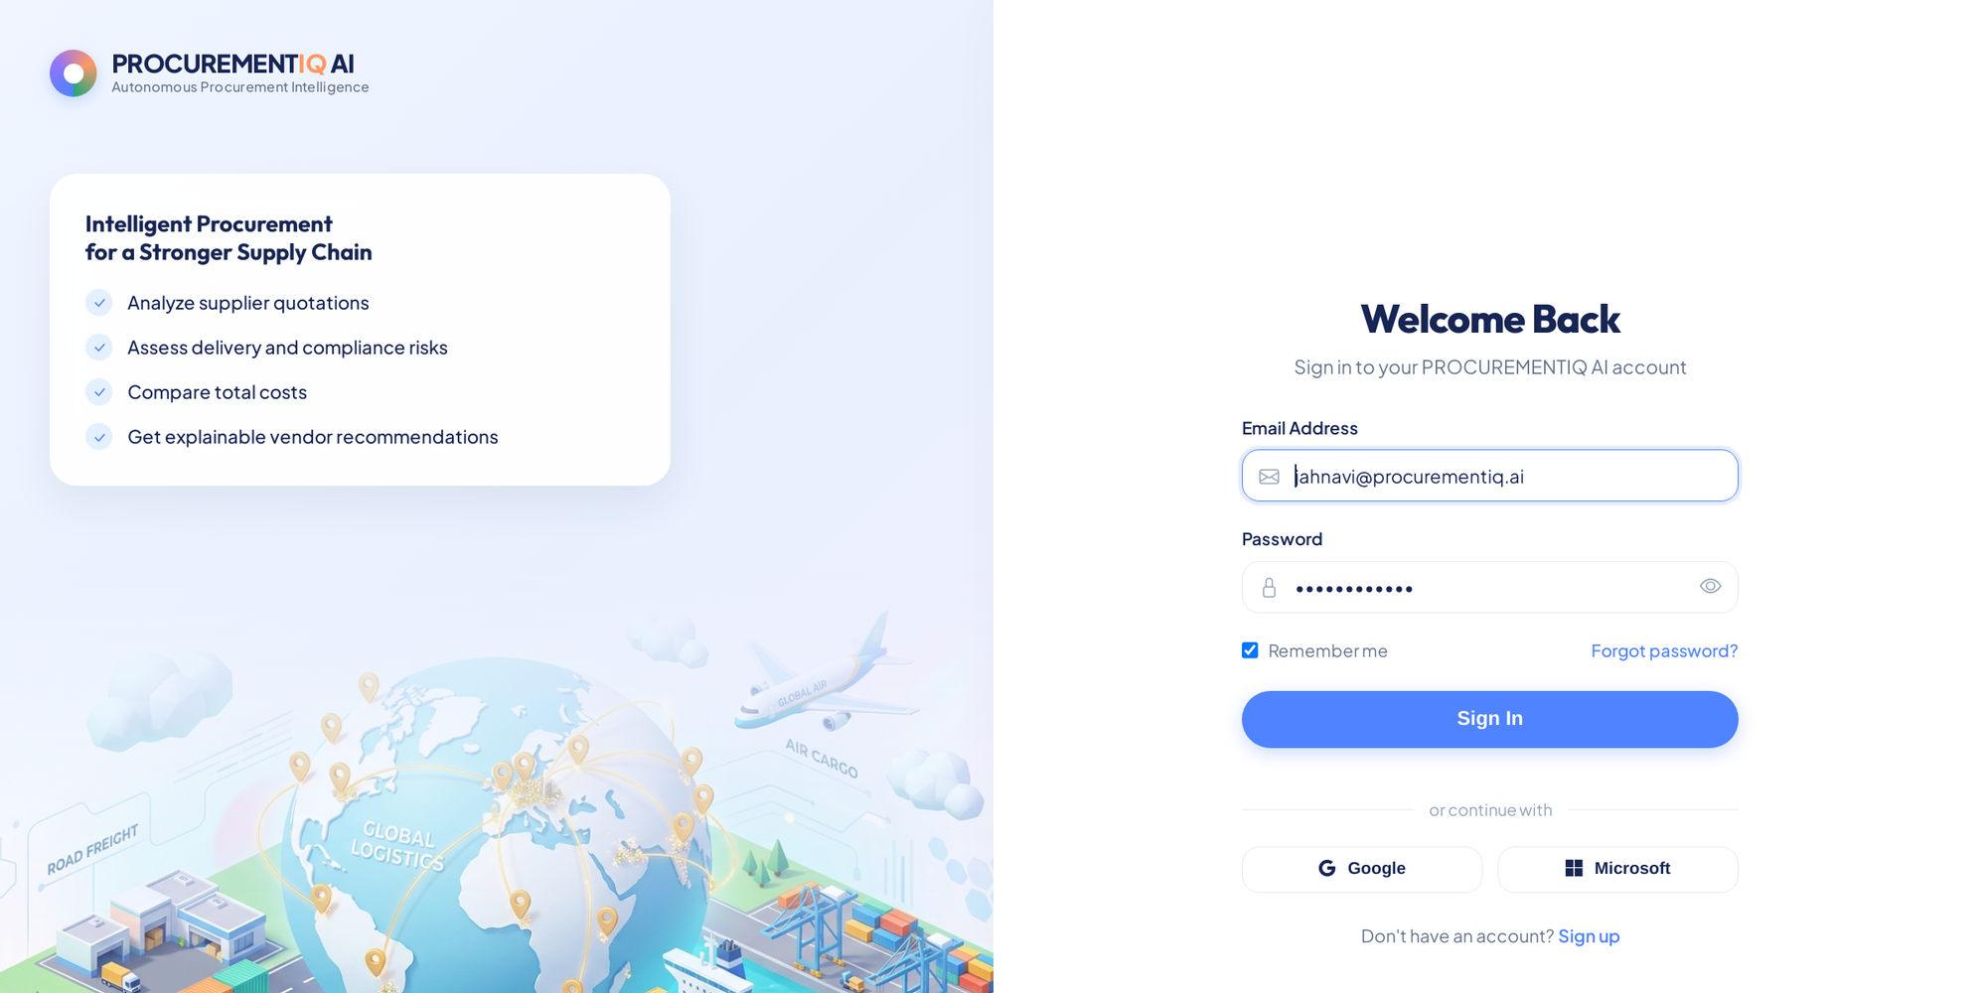
Description: Returning users sign in with their email and password. The page is pre-filled with the seeded demo account so that the app can be tried immediately, and a successful login opens the dashboard.

Dashboard:
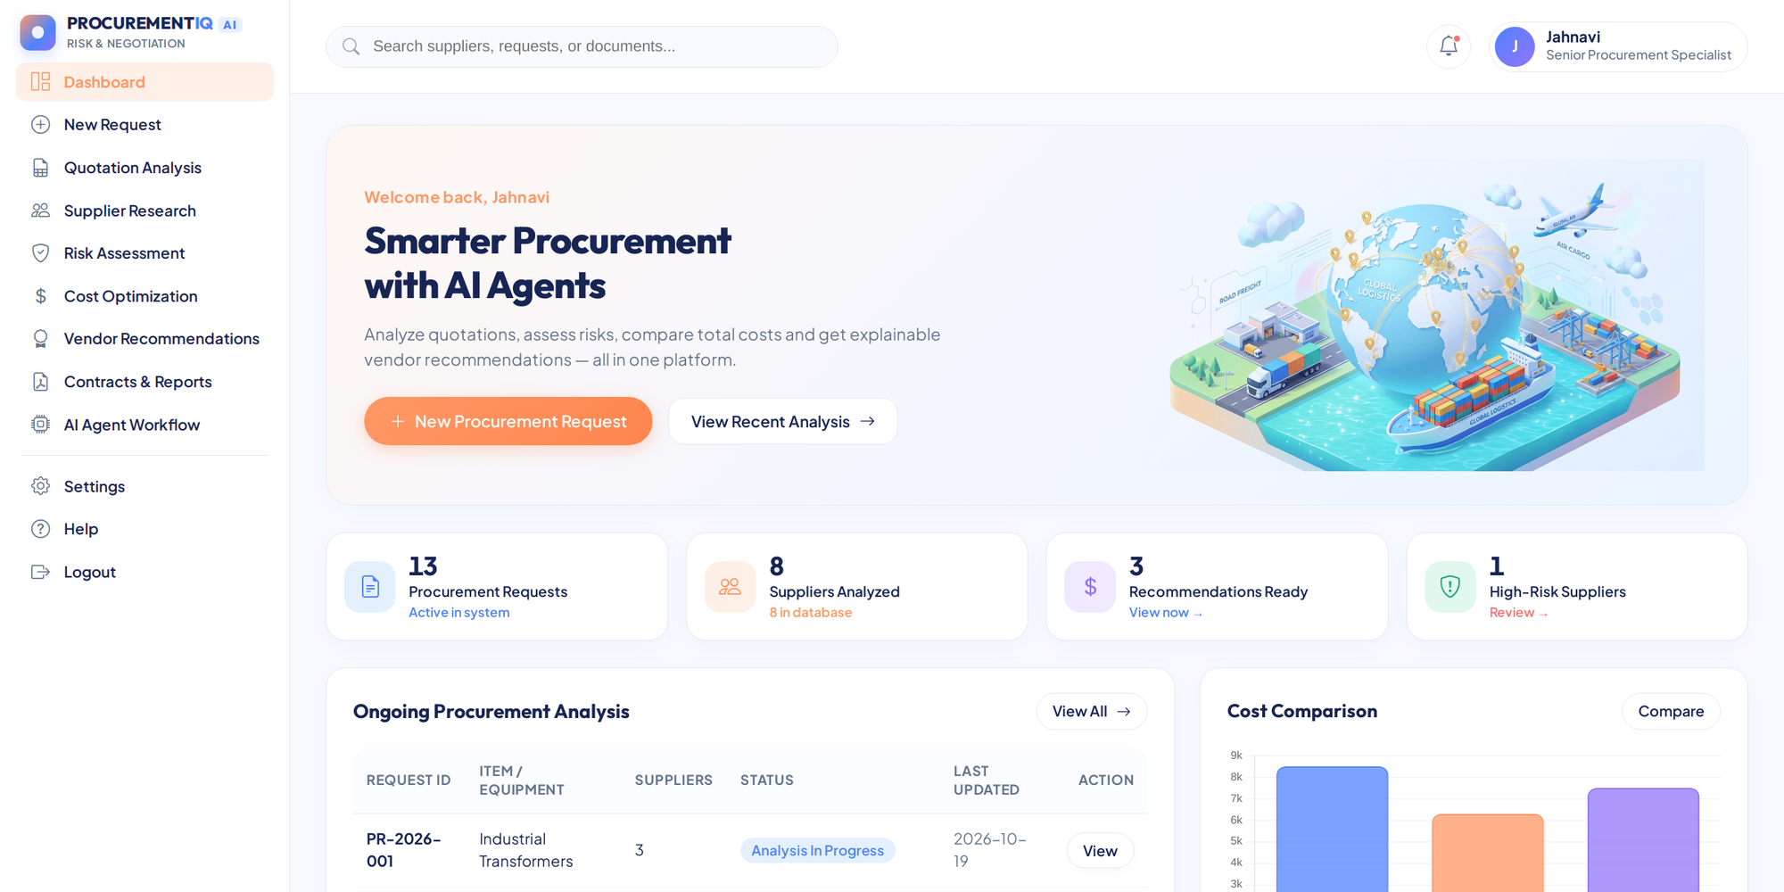
Description: The dashboard greets the signed-in user and shows KPI cards (procurement requests, suppliers analyzed, recommendations ready, and high-risk suppliers) calculated from the database, the table of ongoing procurement analyses with their status, and a cost comparison chart.

New Procurement Request:
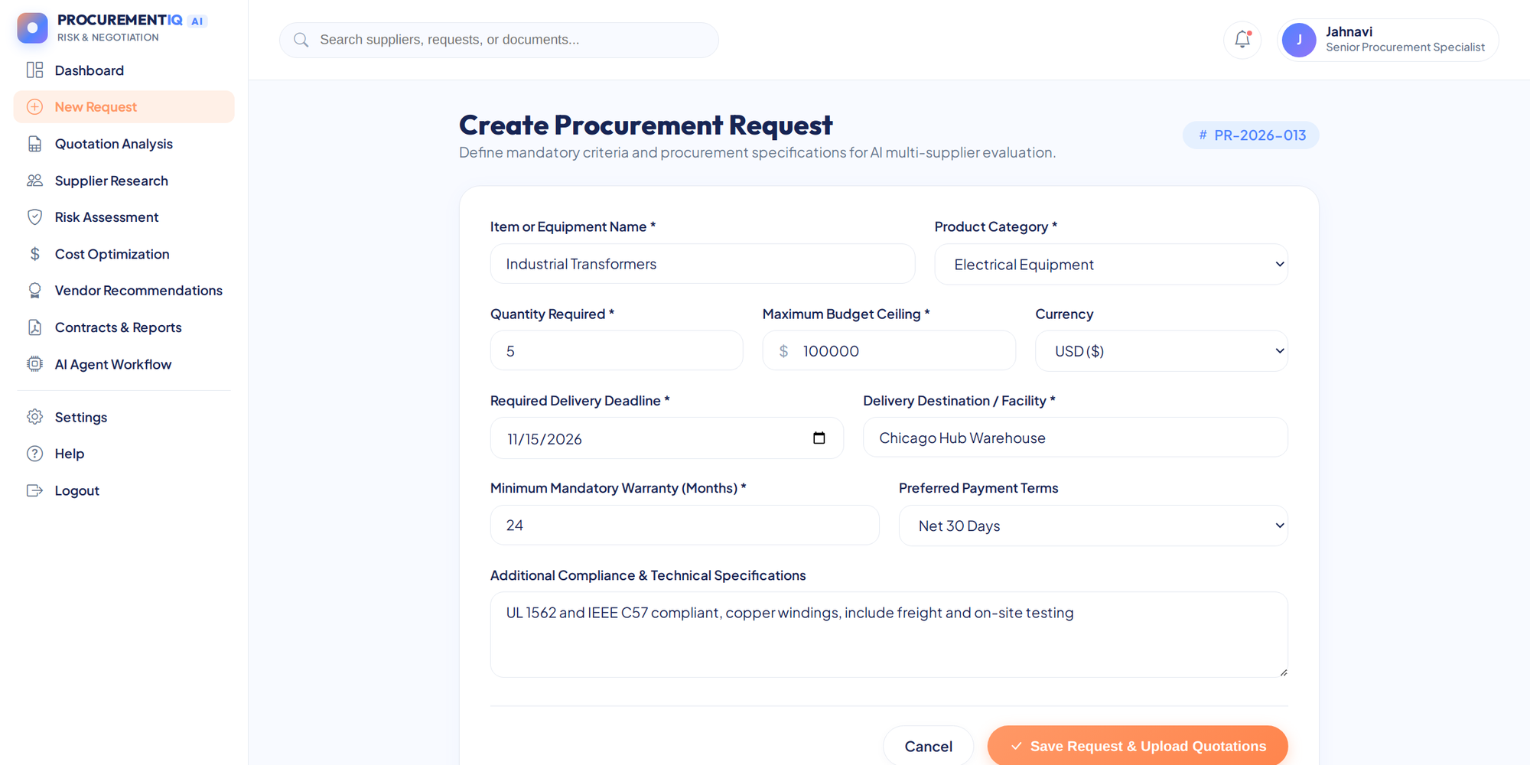
Description: The form collects the item name, category, quantity, maximum budget, currency, required delivery date, delivery location, minimum warranty, payment terms, and any technical requirements. A unique request code such as PR-2026-013 is generated automatically.

Request Details and Quotation Upload:
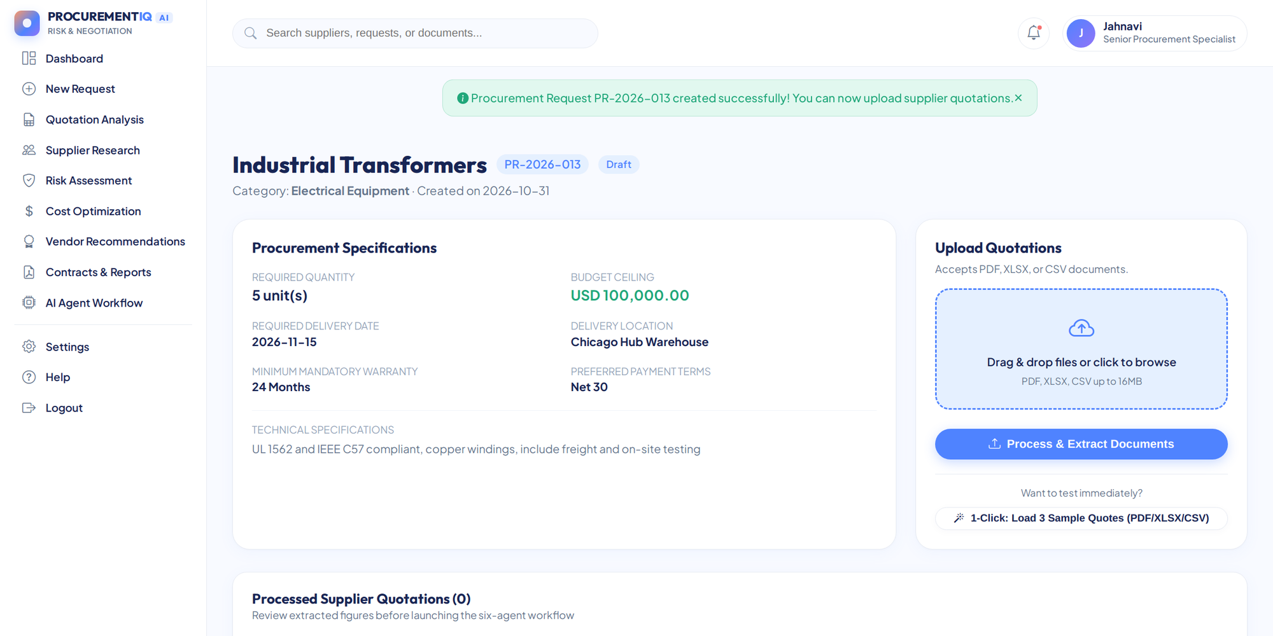
Description: After the request is created, this page summarizes its specifications and offers a drag-and-drop area for PDF, Excel, and CSV quotations, plus a one-click button that loads three sample quotations for testing.

Review and Confirm Quotations:
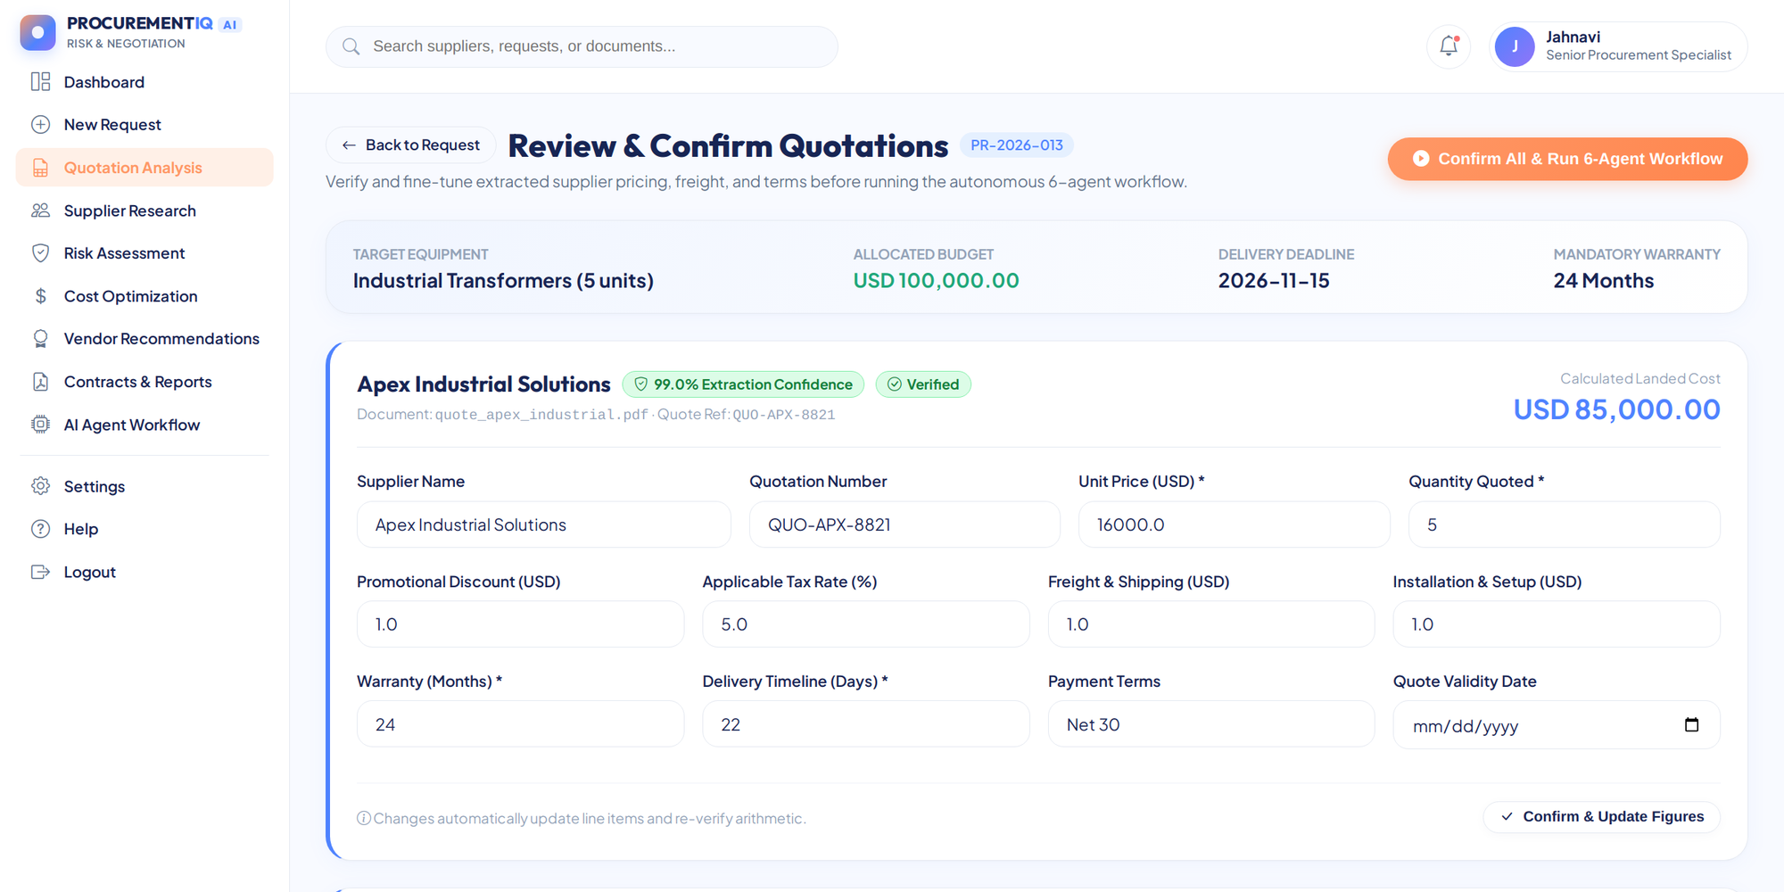
Description: Every uploaded quotation is shown in an editable card with an extraction-confidence badge. The buyer can correct the unit price, quantity, discount, tax rate, shipping, installation, warranty, delivery time, and payment terms, and fields missing from a document are flagged before the agents start.

AI Agent Workflow — Step 1, Requirement Parser:
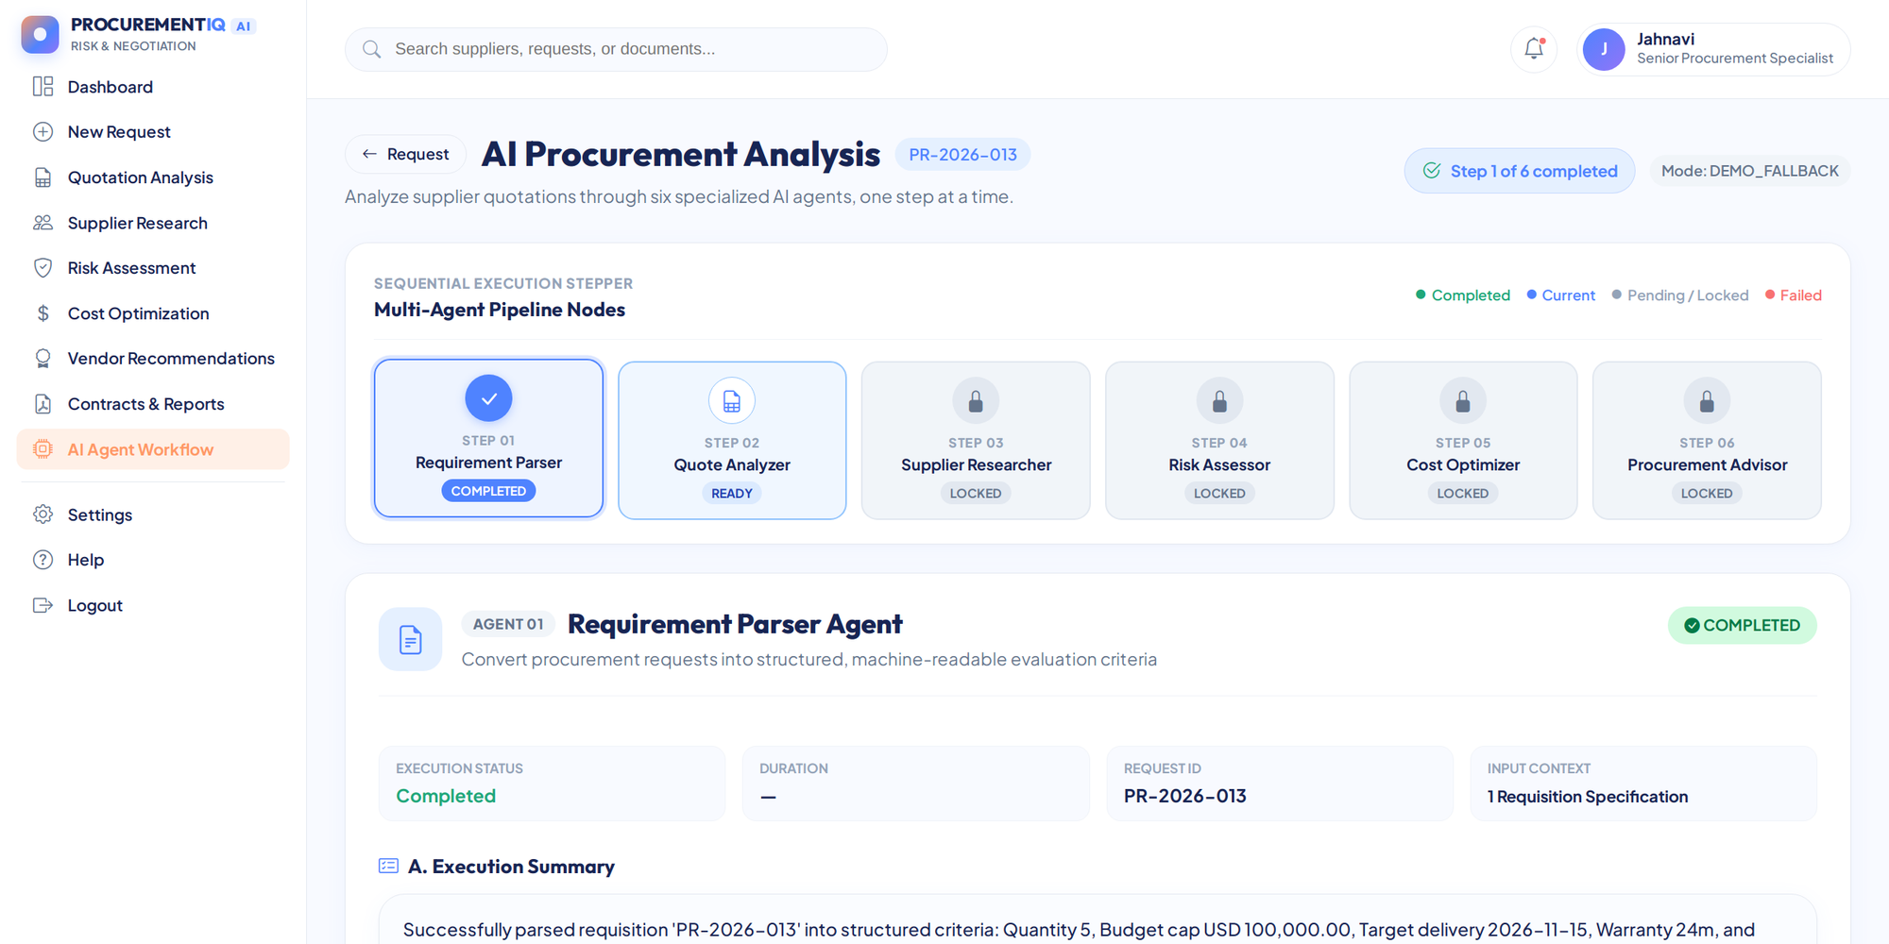
Description: The stepper at the top shows the six agents and their status. Step 1 converts the request into structured mandatory criteria (budget, deadline, warranty) and preferences, and shows the execution summary, the natural-language explanation, and the key findings.

AI Agent Workflow — Step 2, Quote Analyzer:
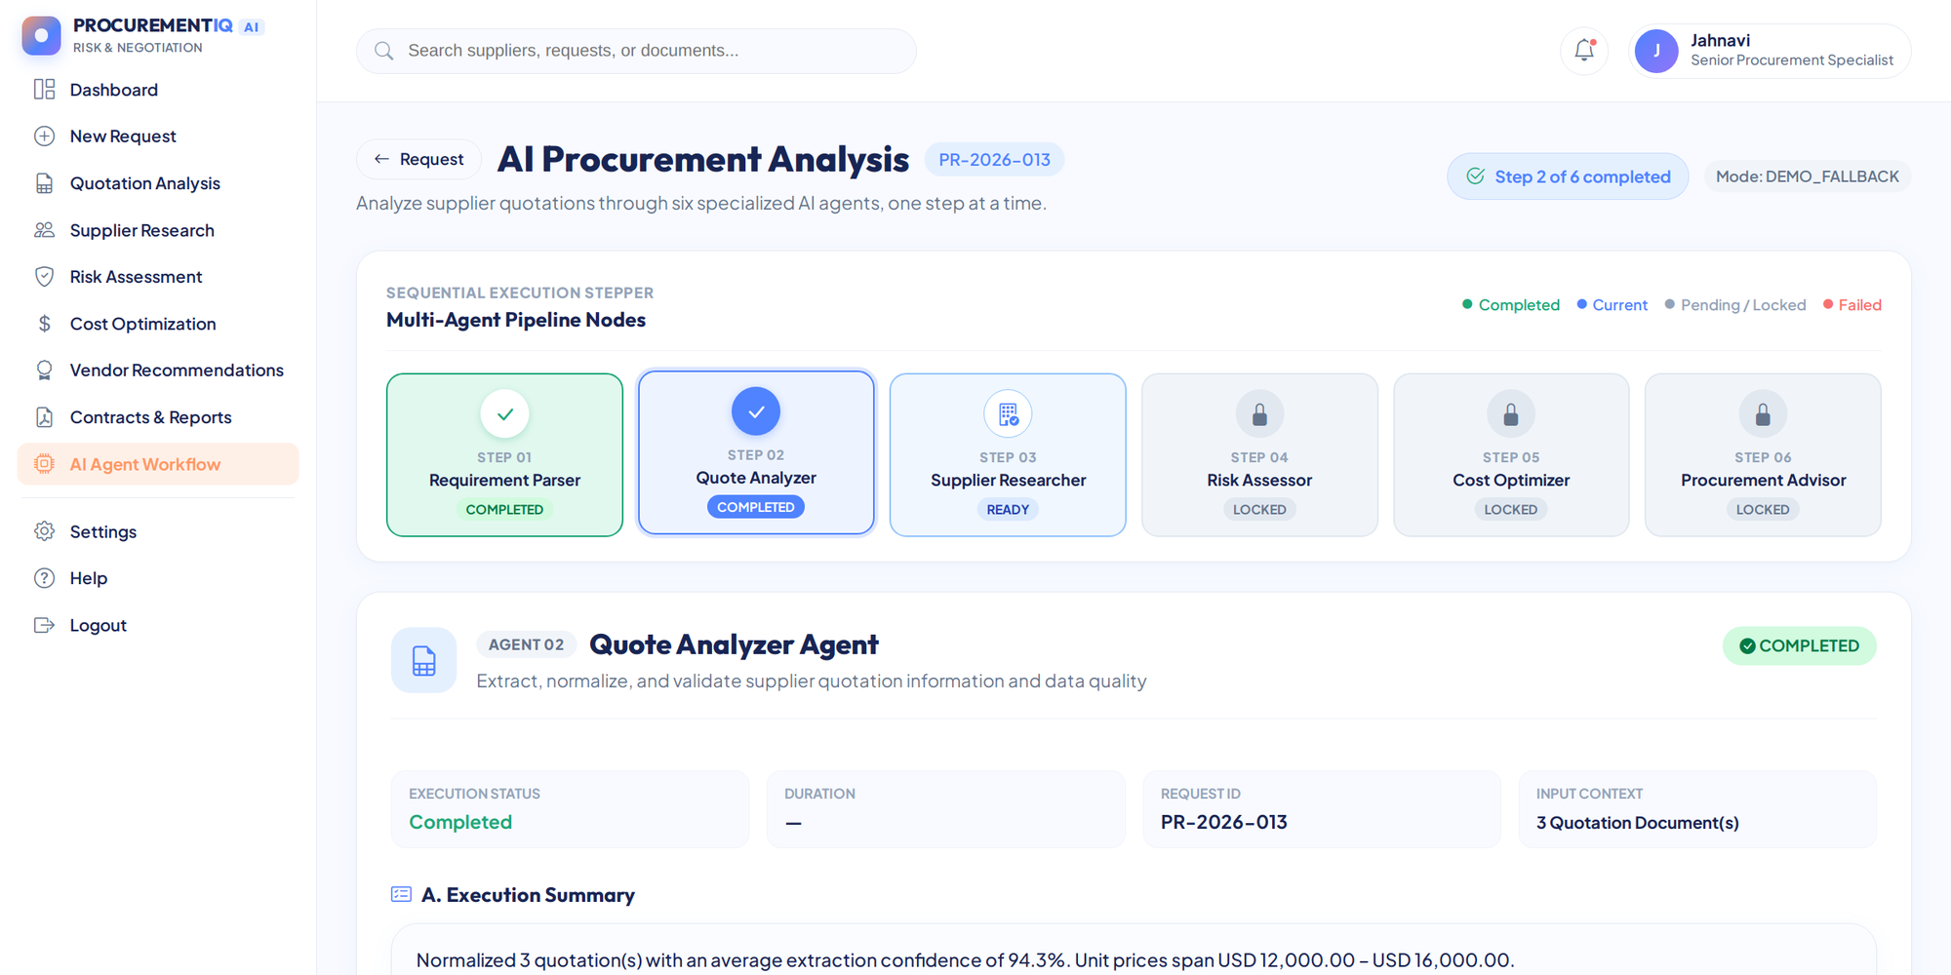
Description: Step 2 normalizes all uploaded quotations, calculates the average extraction confidence, compares unit prices, and lists missing fields that need the buyer’s attention.

AI Agent Workflow — Step 3, Supplier Researcher:
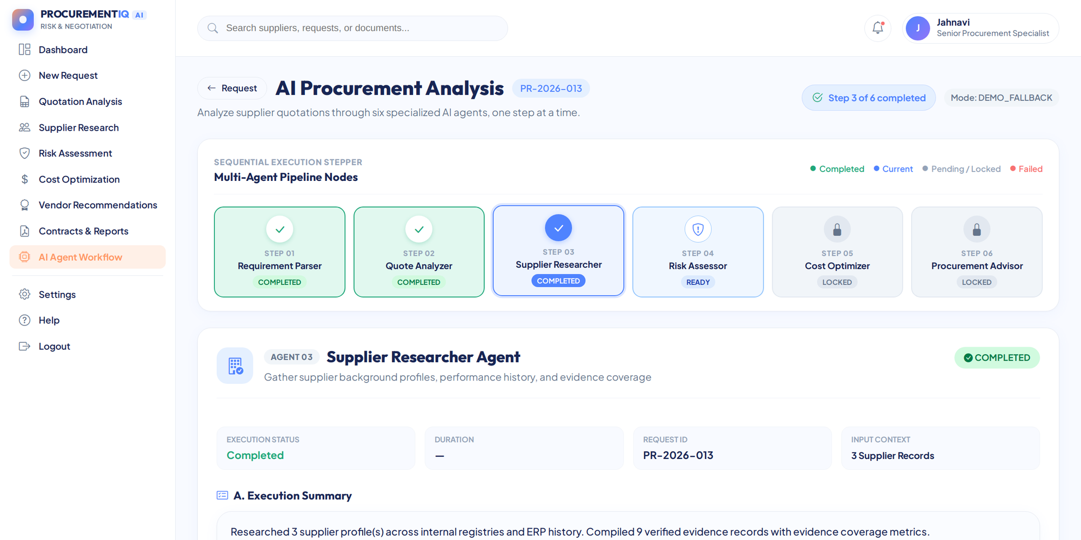
Description: Step 3 builds a profile for each vendor with its on-time delivery rate, defect rate, audit evidence, and information gaps, and records the evidence ledger used by the later agents.

AI Agent Workflow — Step 4, Risk Assessor:
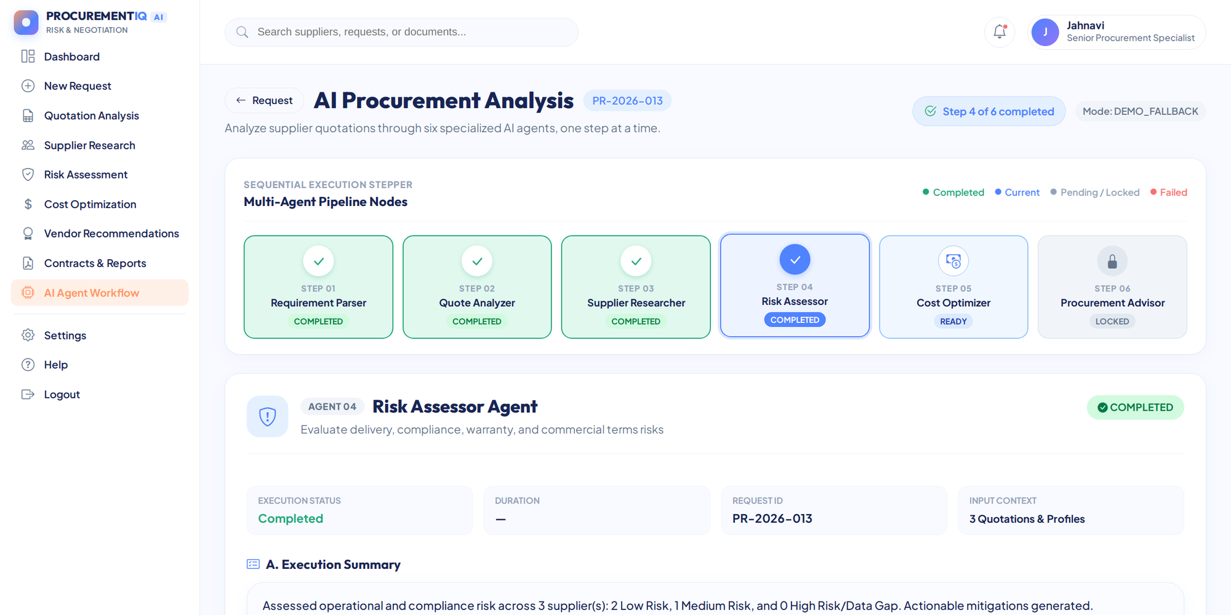
Description: Step 4 rates every supplier for delivery, compliance, dependency, documentation, and commercial-terms risk, gives an overall risk score, and proposes mitigation actions.

AI Agent Workflow — Step 5, Cost Optimizer:
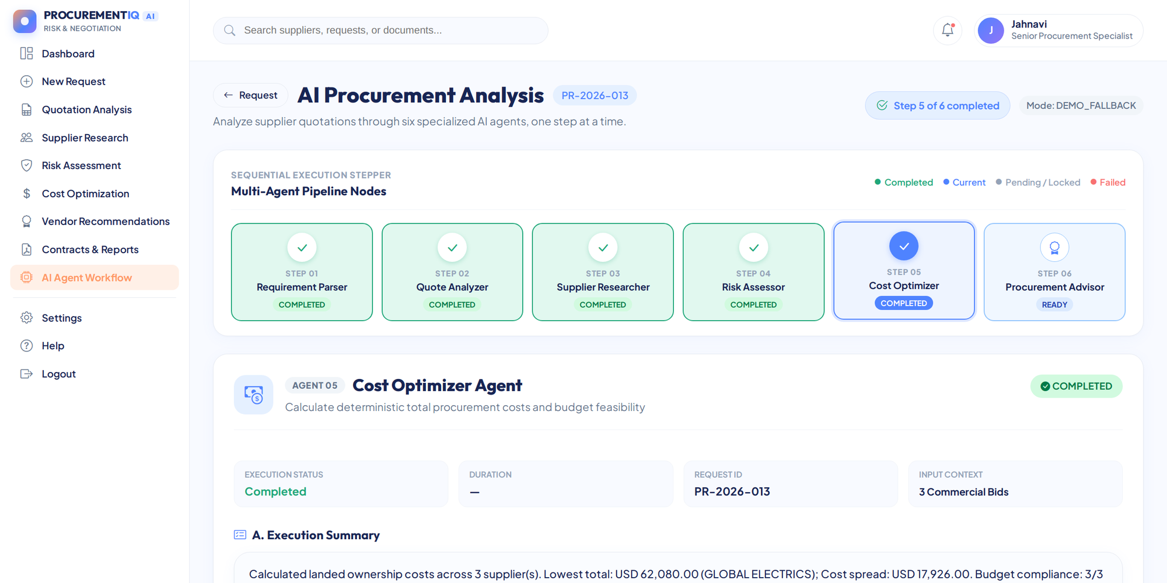
Description: Step 5 calculates the landed cost of each offer, identifies the lowest cost and the price spread, and checks how many offers stay within the approved budget.

AI Agent Workflow — Step 6, Procurement Advisor:
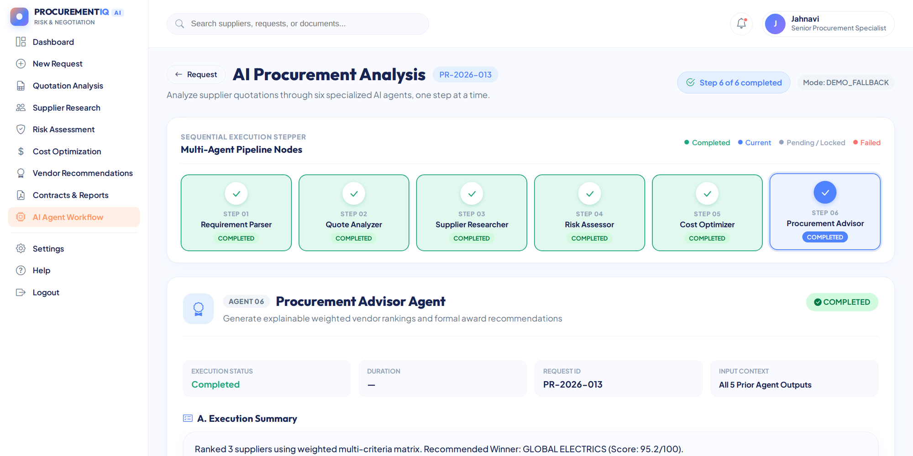
Description: Step 6 ranks all suppliers with the weighted scoring matrix, names the recommended winner, explains why, and lets the buyer approve the recommendation, choose an alternative with a justification, or reject all offers.

Supplier Research & Registry:
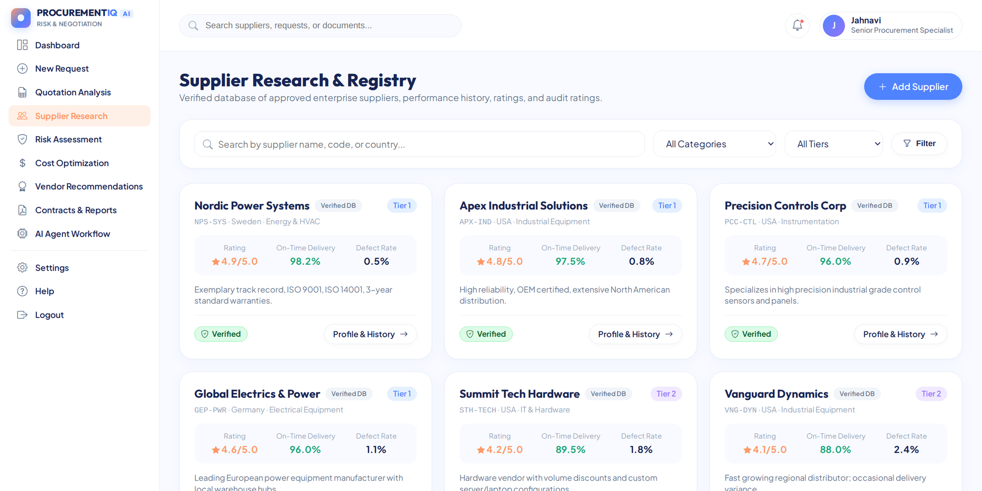
Description: A searchable directory of suppliers with tier, rating, on-time delivery rate, defect rate, and verification status, with filters by category and tier and a button to add a new supplier.

Supplier Profile:
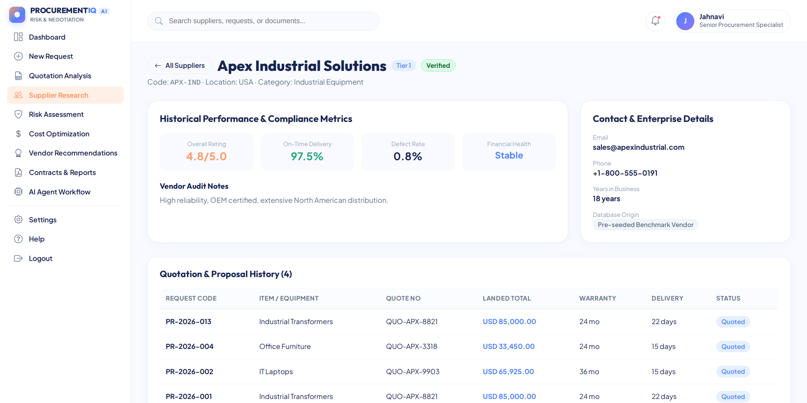
Description: The profile shows historical performance and compliance metrics, enterprise contact details, audit notes, and the supplier’s quotation and proposal history across requests.

Risk Assessment:
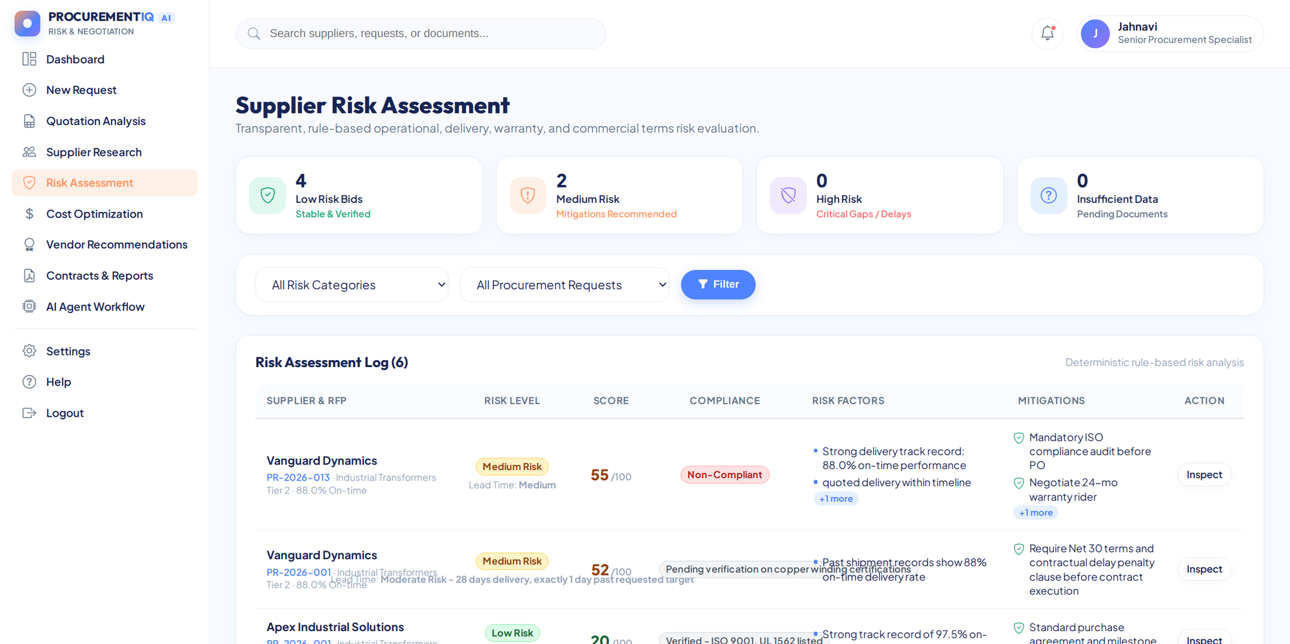
Description: The risk register summarizes low, medium, and high risk bids and lists every supplier with its risk level, score, compliance status, risk factors, and recommended mitigations, with filters by category and request.

Risk Assessment Report:
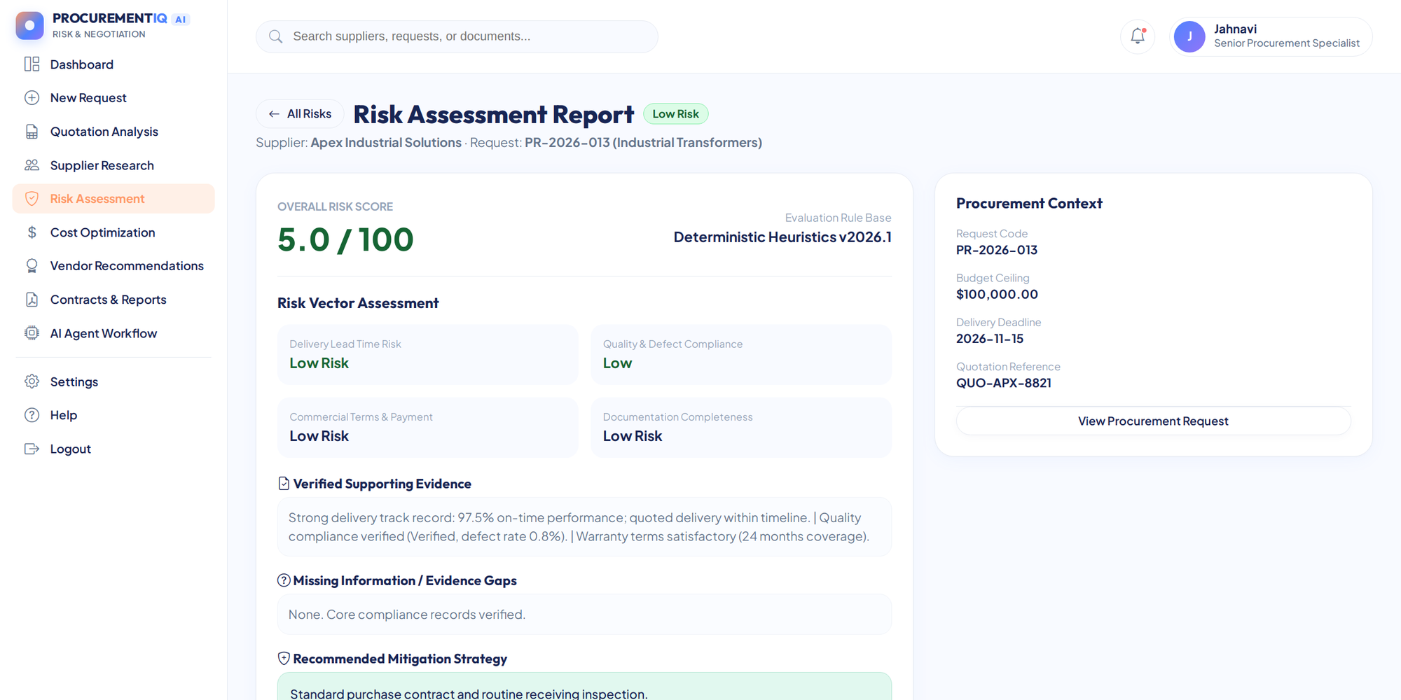
Description: A detailed report for one supplier showing the overall risk score, the risk vector assessment, verified supporting evidence, missing information, and the recommended mitigation strategy.

Cost Optimization:
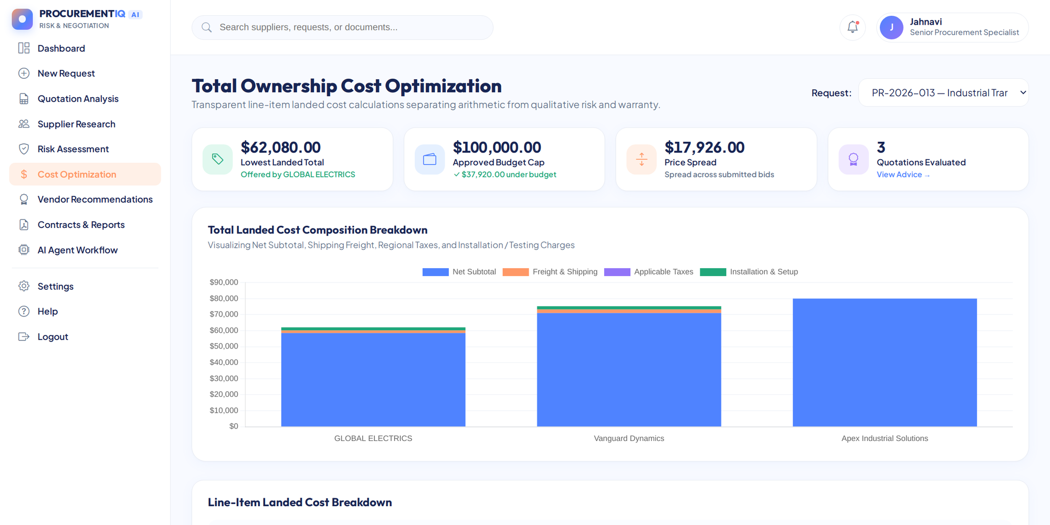
Description: Total ownership cost is compared across suppliers with KPI cards for the lowest landed total, the approved budget, and the price spread, a stacked chart of net subtotal, freight, taxes, and installation, and a line-item cost breakdown table.

Vendor Recommendations:
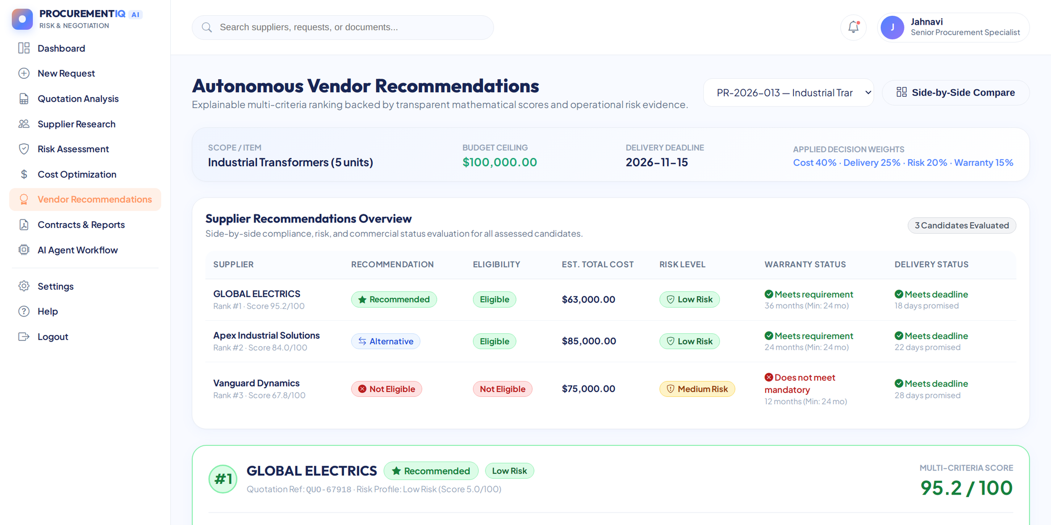
Description: The ranked supplier table shows eligibility, estimated total cost, risk level, warranty, and delivery status, while the winner card shows the composite score with the cost, delivery, risk, and warranty breakdown and the negotiation tips.

Executive Contracts & Reports:
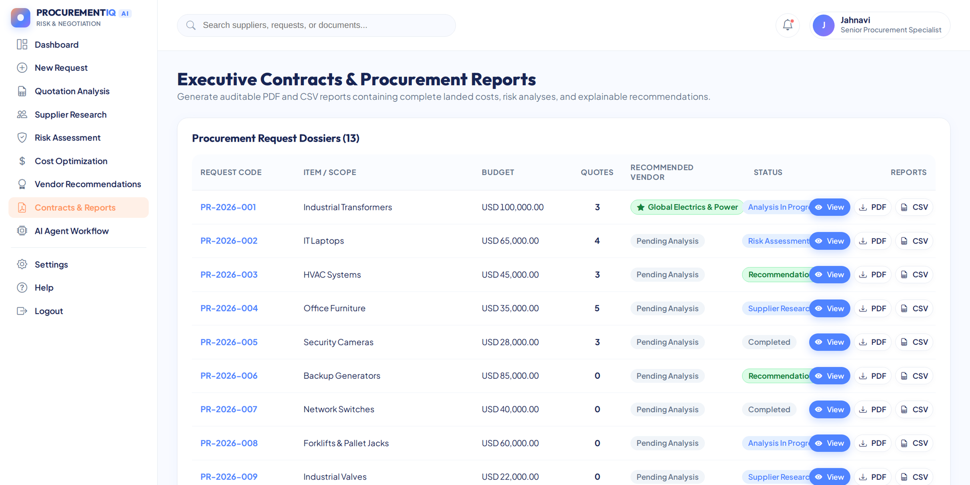
Description: All procurement requests are listed with their budget, number of quotes, recommended vendor, and status, and each row offers a download of the executive PDF report and the CSV data export.

Settings:
Description: Users can adjust the four scoring weights (cost, delivery, risk, warranty), choose the purchasing currency, and manage the API keys, with a connection test for Gemini.

Conclusion:
ProcurementIQ AI is an AI-powered procurement intelligence platform built with Flask, SQLite, and a six-agent architecture. It converts supplier quotations in PDF, Excel, and CSV format into explainable vendor rankings by combining deterministic cost, risk, and scoring engines with optional Gemini-generated explanations, and it keeps the final award decision with the human buyer. Running in offline DEMO MODE or with a Gemini key, with executive PDF and CSV exports and public sharing through Ngrok, the project demonstrates how multi-agent workflows can make procurement faster, more transparent, and easier to audit.

